**Fund Overview**

**Funds in Court**

Common Fund No. 2

Annual Fact Sheet - 30 June 2025

Common Fund No. 2 (CF-2) provides clients with exposure to a low risk portfolio of defensive, income producing assets. The Fund invests primarily in a combination of ‘at-call’ cash, term deposits and high quality fixed income securities/bonds.

**Fund Objective**

To provide the maximum possible return with an emphasis on income and capital preservation over the medium to long term via investment in approved securities.

**Asset Allocation**

**Figure 1. Current CF-2 asset allocation**

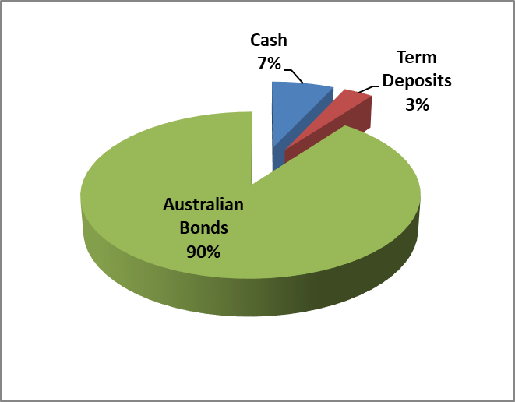

**Sector exposure**

**Figure 2. Current CF-2 holdings by sector**

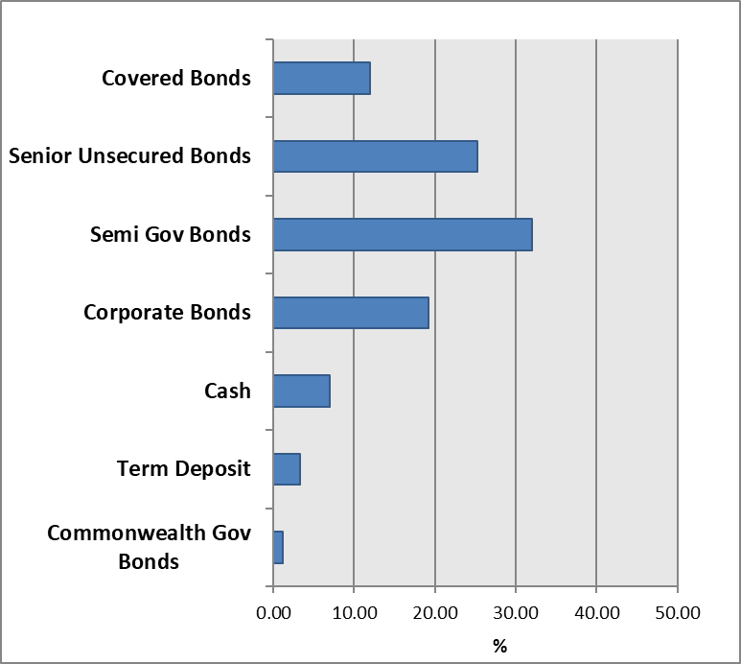

**Income and Crediting Rate**

Income earned by CF-2 is accrued daily and credited annually to the account of clients (normally on or around 1 June). The crediting rate is determined by the total gross income earned from

CF-2 investments over the preceding 12 month period ending 31 May, less the partial recoup of office operating costs.

For the 12 month period ending 31 May 2025, the gross return of CF-2 was 3.71%. Following the deduction of office operating costs, an annual crediting rate of 2.75% was declared for clients invested in CF-2 only#, and 2.55% for clients invested in both CF-2 and CF-3# as at 1 June 2024.

An interim rate of 1.55% was credited to the account of clients if their funds were paid out of Court during the year.

**Annual Crediting Rate**

**Figure 3. CF-2 & RBA rates over past 5 years**

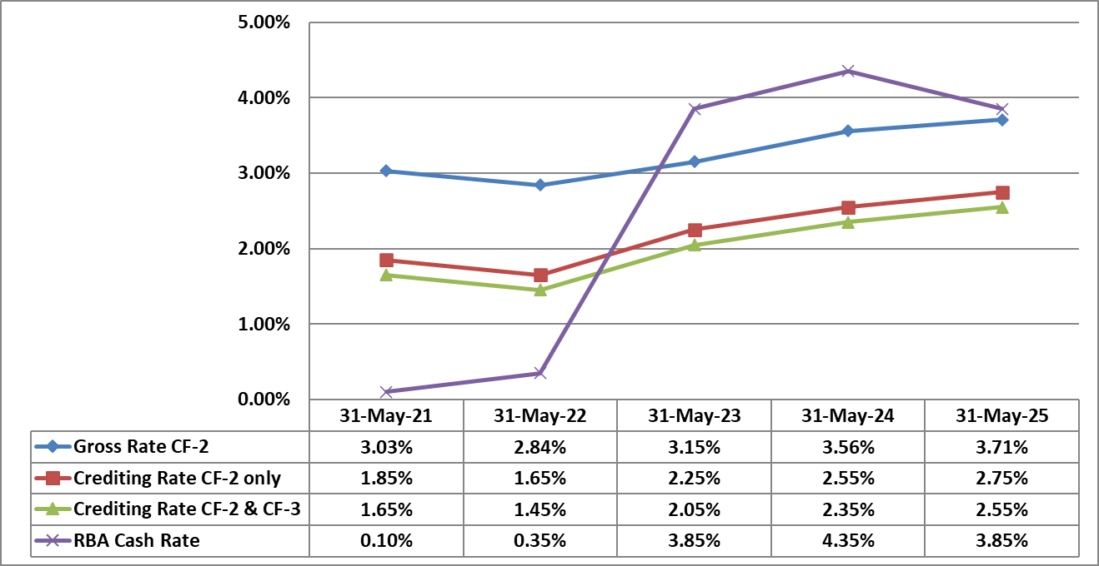

# Since 2011, two separate crediting rates have been declared for CF-2. This means that clients with funds invested in both CF-2 and Common Fund No. 3 (CF-3) are paid a CF-2 crediting rate that is 0.20% p.a. less than the crediting rate declared for clients invested only in CF-2. This approach helps to cover the costs of administering CF-3.

**Figure 4. Growth of $10,000 invested and compounded in CF-2 & RBA rates over past 5 years**

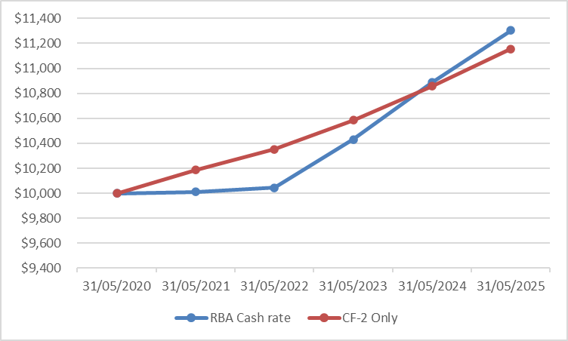

**Commentary**

The Fund’s crediting rates increased by 0.20% compared to the previous twelve months’ rates. The income return generated by the Fund is linked to the official cash rate as set by the Reserve Bank of Australia (RBA) as well as bond yields.

During the financial year, the RBA cut the official cash rate twice, once in February 2025 by 0.25%, and the second time in May 2025 by a further 0.25% to be at its current level of 3.85%.

However, bond yields were much more volatile throughout the financial year with a combination of inflation data, the expectations of central bank actions in relation to interest rates and evolving trade tensions and policy uncertainty continuing to be the main factors driving bond markets. For example, the 10-year Australian Government bond traded at 4.41% as at 30 June 2024 and during the first part of the financial year this yield dropped to a low of 3.81% in mid-September 2024 as inflationary pressures eased, the U.S. central bank started cutting interest rates and the RBA was expected to soon follow suit. However, this yield then increased sharply to get to a high of 4.72% by mid-November 2024 as the U.S. election outcome become clear, and the resultant trade policy uncertainty this created, along with strong economic data, led to central banks signalling a slower pace of interest rate cuts than what was previously expected. The 10-year Australian Government bond yield then traded in a range of 4.65% to 4.12% throughout the second half of the financial year, driven mainly by trade tensions and related tariff announcements between the U.S. and other countries and ended the financial year at a level of 4.18%.

The current relatively higher interest rate environment compared to the historic lows of a few years ago will provide opportunities to reinvest bonds at more attractive rates than what was on offer over that time, which is more favourable for future income for the fund.

**NEED FURTHER INFORMATION?**

**For further information on how we manage your funds please visit the FIC website at www.fundsincourt.vic.gov.au or call 1300 039 390 to speak to a member of staff.**

**Fund Details**

|  |  |
| --- | --- |
| **Portfolio Statistics** |  |
| Market Value | $1,038m |
| Number of Holdings | 86 |
| Portfolio Duration | 4.10 years |
| Market Yield | 4.26% |

|  |  |
| --- | --- |
| **Top 10 Holdings (Market Value) excl. Cash (Coupon, Maturity)** | **%** |
| NSWTC Semi Gov (3.00%, 20 Feb 2030) | 5.18 |
| WBC Covered Bond PP (3.05%, 5 April 2034) | 4.32 |
| WBC Covered Bond PP (2.95%, 16 May 2034) | 4.26 |
| SAFA Semi Gov (2.75%, 24 May 2030) | 3.59 |
| NAB MTN (4.85%, 22 March 2029) | 3.11 |
| WBC Term Deposit (4.35%, 12 May 2026) | 2.41 |
| WBC MTN (4.30%, 19 June 2030) | 2.32 |
| TCV Semi Gov (1.50%, 10 Sept 2031) | 2.31 |
| QTC Semi Gov (5.00%, 21 July 2037) | 2.08 |
| QTC Semi Gov (5.25%, 21 July 2036) | 2.00 |

|  |  |
| --- | --- |
| **Holdings by Long Term Credit Rating (excl. Cash & Term Deposits < 1 year)** | **%** |
| AAA | 15.8 |
| AA+ | 22.5 |
| AA | 8.9 |
| AA- | 31.4 |
| A+ | 12.5 |
| A | 1.2 |
| A- | 4.4 |
| BBB+ | 2.0 |
| BBB | 1.3 |

|  |  |
| --- | --- |
| **Maturity Profile** | **%** |
| 0 – 1 year | 19.2 |
| 1 – 3 years | 11.5 |
| 3 – 5 years | 35.3 |
| 5 – 10 years | 21.8 |
| 10+ years | 12.2 |