Fund Overview

Funds in Court

Common Fund No. 2

Annual Fact Sheet - 30 June 2021

Common Fund No. 2 [CF-2] provides beneficiaries with exposure to a low risk portfolio of defensive, income producing assets. The Fund invests primarily in a combination of ‘at-call’ cash, term deposits and high quality fixed income securities/ bonds.

Fund Objective

To provide the maximum possible return with an emphasis on income and capital preservation over the medium to long term via investment in approved securities.

Asset Allocation

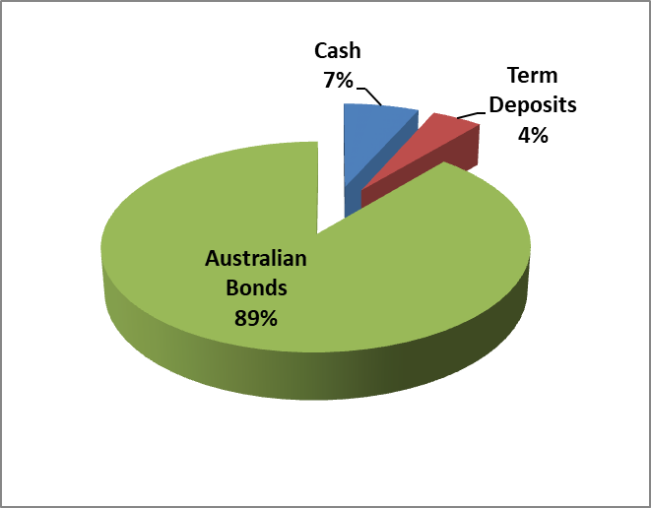

Sector Exposure

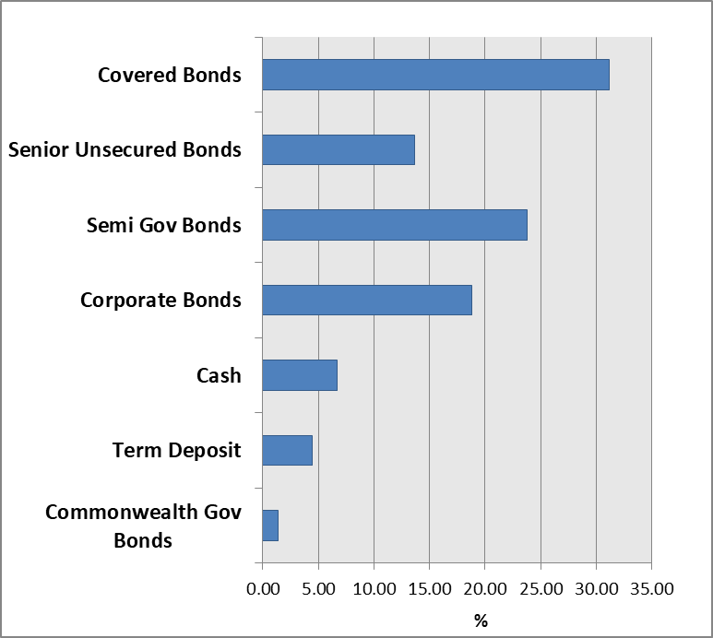
Interest & Crediting Rate
NEED FURTHER INFORMATION?
For further information on how we manage your funds please visit the FIC website at www.fundsincourt.vic.gov.au or call 1300 039 390 to speak to a member of staff.
Interest earned by CF-2 is accrued daily and credited annually to the account of beneficiaries (normally on or around 1 June). The crediting rate is determined by the total gross income earned from CF-2 investments over the preceding 12 month period ending 31 May, less, the partial recoup of office operating costs. An interim rate equivalent to the Reserve Bank of Australia official cash rate is credited to the account of beneficiaries if their funds are paid out of Court during the year.

Since 2011, two separate annual crediting rates have been declared for CF-2. This means that beneficiaries with funds invested in both CF-2 and Common Fund No. 3 [CF-3] are paid a CF-2 crediting rate, that is, 0.20% p.a. less than the crediting rate declared for beneficiaries invested only in CF-2. This approach helps to cover the costs of administering CF-3.

For the 12 month period ending 31 May 2021, the gross interest return of CF-2 was 3.03%. Following the deduction of office operating costs an annual crediting rate of 1.85% was declared for beneficiaries invested in CF-2 only, and 1.65% for beneficiaries invested in both CF-2 and CF-3 as at 1 June 2020. The gross earnings rate and crediting rate for CF-2 over the last five years are shown below.

Annual Crediting Rate

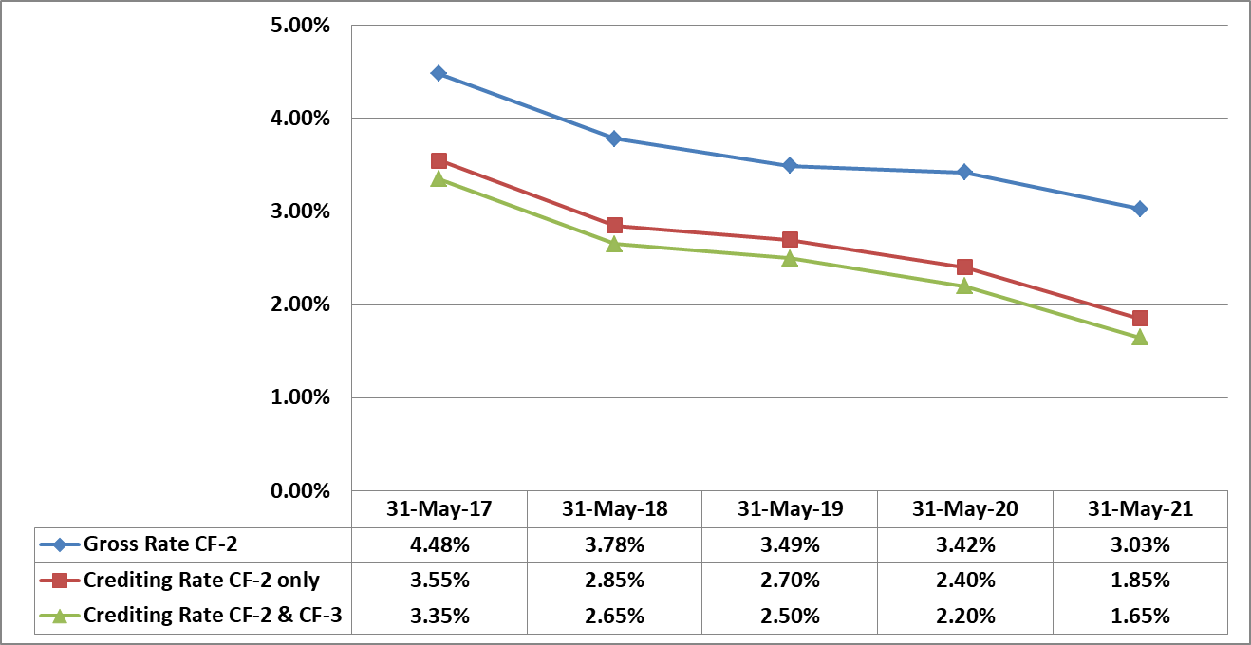

Commentary

The income return generated by the Fund is closely linked to the official cash rate as set by the Reserve Bank of Australia [RBA] as well as bond yields. Both of these measures reached new historical lows during the financial year and contributed to the decline in the Fund’s annual crediting rate declared on 1 June 2021.

In November 2020 the RBA lowered the official cash rate by 0.15% to a historical low of 0.10%, where it has remained throughout the rest of the financial year, and introduced further measures to try and keep interest rates relatively low in order to support job creation and the recovery of the economy from the pandemic.

The 10 year Australian Government bond yield traded at 1.53% as at 30 June 2021 (compared to 0.87% 12 months prior). This yield was relatively steady throughout the first half of the financial year where it generally hovered between the range of 0.80% and 1%. However, the second half of the financial year was a period of significant volatility in 10 year yields where they increased strongly early in 2021 to levels around 1.92% on concerns of rising inflation expectations which may trigger central banks to increase cash rates earlier than expected. Central banks however, reiterated their accommodative stance on keeping interest rates lower for longer and tempered these expectations, thus the 10 year bond yields steadily reduced from these elevated levels during the remainder of the financial year.

In the current low interest rate environment we have continued to seek ways to maximise the yield of the portfolio without compromising the high quality/ low risk nature of the portfolio’s investments.
IMPORTANT NOTE:
For further information on the investment risks associated with CF-2 and how FIC seeks to minimise these risks, please refer to the relevant Information Guide on our website at www.fundsincourt.vic.gov.au

Fund Details

Portfolio Statistics
Market Value | $942.1m
Number of Holdings | 39
Portfolio Duration | 4.72 years
Market Yield | 1.23%

Top 10 Holdings (Market Value) excl. Cash  (Coupon, Maturity) | %
NSWTC Semi Gov (3.00%, 20 Feb 2030) | 6.56
CBA Covered Bond (4.50%, 10 July 2024) | 6.01
CBA Covered Bond (4.275%, 26 Aug 2024) | 5.96
Toyota Finance MTN (3.10%, 19 May 2022) | 5.89
WBC Covered Bond (3.875%, 4 June 2025) | 5.85
WBC Covered Bond PP (3.05%, 5 April 2034) | 5.54
WBC Covered Bond PP (2.95%, 16 May 2034) | 5.46
ANZ MTN (3.10%, 8 Feb 2024) | 4.80
SAFA Semi Gov (2.75%, 24 May 2030) | 4.52
TCV Semi Gov (1.50%, 10 Sept 2031) | 2.90

Holdings by Long Term Credit Rating  (excl. Cash & Term Deposits < 1 year) | %
AAA | 36.6
AA+ | 19.2
AA | 6.3
AA- | 23.6
A+ | 13.1
A | 0.0
A- | 1.2

Maturity Profile | %
0 – 1 year | 15.6
1 – 3 year | 24.6
3 – 5 year | 20.7
5 – 10 year | 19.3
10+ years | 19.8

