Fund Overview

Funds in Court

Common Fund No. 2

Annual Fact Sheet - 30 June 2023

Common Fund No. 2 [CF-2] provides beneficiaries with exposure to a low risk portfolio of defensive, income producing assets. The Fund invests primarily in a combination of ‘at-call’ cash, term deposits and high quality fixed income securities/ bonds.

Fund Objective

To provide the maximum possible return with an emphasis on income and capital preservation over the medium to long term via investment in approved securities.

Asset Allocation

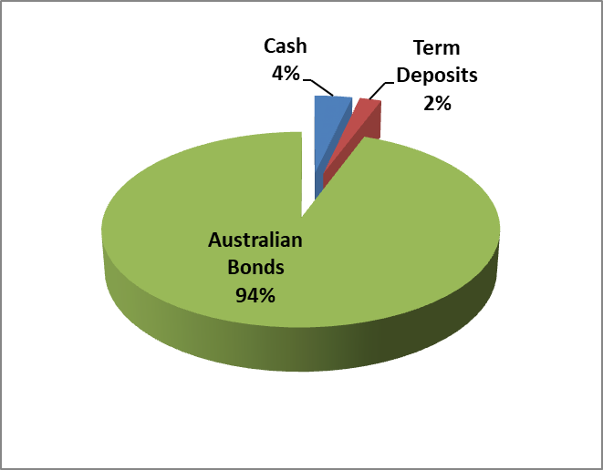

Sector Exposure

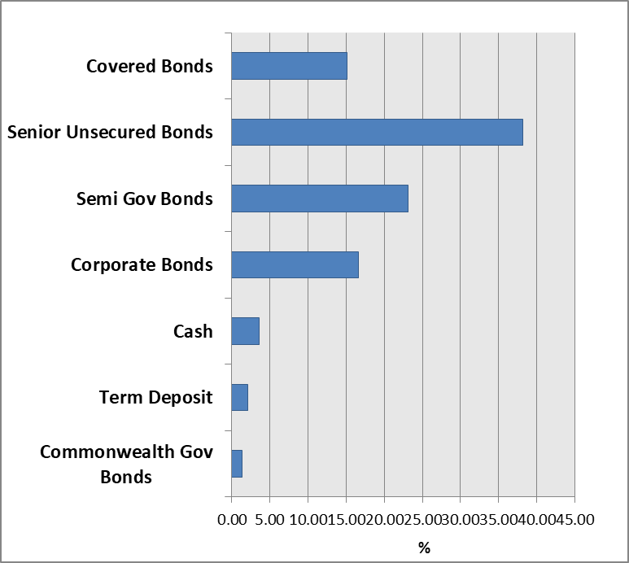
Interest & Crediting Rate
NEED FURTHER INFORMATION?
For further information on how we manage your funds please visit the FIC website at www.fundsincourt.vic.gov.au or call 1300 039 390 to speak to a member of staff.
Interest earned by CF-2 is accrued daily and credited annually to the account of beneficiaries (normally on or around 1 June). The crediting rate is determined by the total gross income earned from CF-2 investments over the preceding 12 month period ending 31 May, less, the partial recoup of office operating costs. An interim rate of 0.70% was credited to the account of beneficiaries if their funds were paid out of Court during the year.

Since 2011, two separate annual crediting rates have been declared for CF-2. This means that beneficiaries with funds invested in both CF-2 and Common Fund No. 3 [CF-3] are paid a CF-2 crediting rate that is 0.20% p.a. less than the crediting rate declared for beneficiaries invested only in CF-2. This approach helps to cover the costs of administering CF-3.

For the 12 month period ending 31 May 2023, the gross interest return of CF-2 was 3.15%. Following the deduction of office operating costs an annual crediting rate of 2.25% was declared for beneficiaries invested in CF-2 only, and 2.05% for beneficiaries invested in both CF-2 and CF-3 as at 1 June 2022. The gross earnings rate, crediting rate for CF-2 and RBA Cash Rate over the last five years are shown below.

Annual Crediting Rate

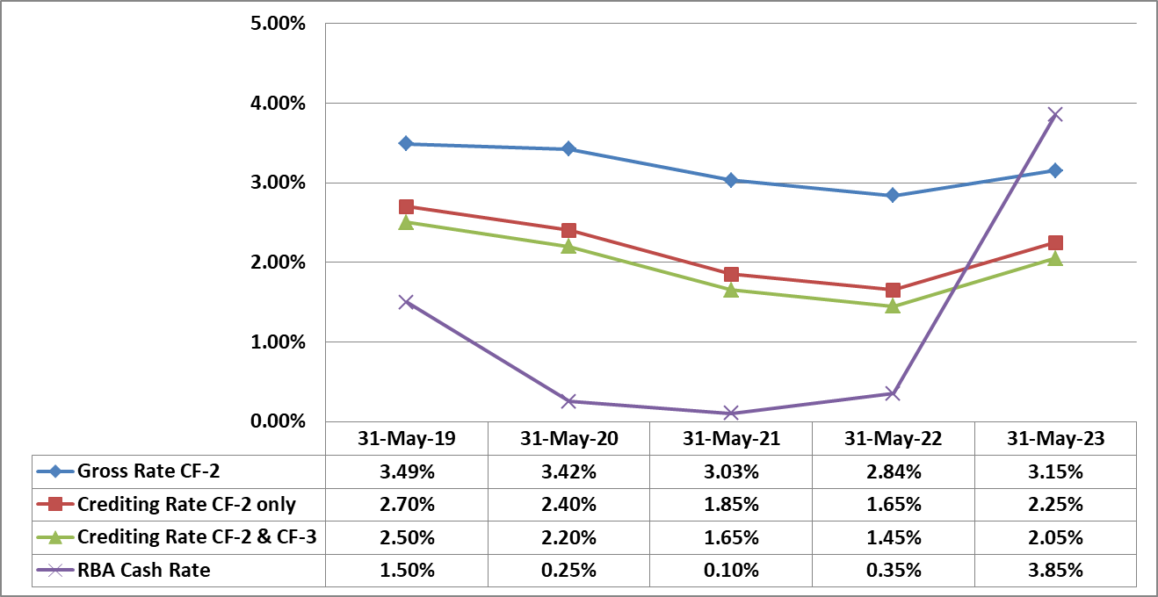

Commentary

The funds crediting rates increased by 0.60% compared to the previous twelve months’ rates.

During the financial year we saw the Reserve Bank of Australia [RBA] raise the official cash rate ten times from 0.85 in June 2022 to 4.10% in June 2023.
A combination of inflation data, central bank actions and interest rates continued to be the main factors driving fixed interest rate markets over the 2022/2023 financial year. Central banks around the world continued to raise interest rates in an attempt to bring inflation down. The year was a relatively volatile one, with the 10-year Australian bond yield, for example, raising 0.30% during the year from 3.69% to 3.99% but falling as low as 3.19%.

Throughout the period the fund has been in a shorter duration position compared to the benchmark, which is a defensive position with the expectation that the cash rate was anticipated to continue to rise a little further and the potential for bond yields to also increase further. The increased yields will provide opportunities to reinvest bonds at more attractive rates than what was on offer over the recent years, which is more favourable for future income for the fund.

Fund Details
Portfolio Statistics
Market Value | $901.972m
Number of Holdings | 59
Portfolio Duration | 3.48 years
Market Yield | 4.92%

Top 10 Holdings (Market Value) excl. Cash  (Coupon, Maturity) | %
NSWTC Semi Gov (3.00%, 20 Feb 2030) | 5.68
CBA Covered Bond (4.275%, 26 Aug 2024) | 5.56
CBA Covered Bond (4.50%, 10 July 2024) | 5.49
WBC Covered Bond (3.875%, 4 June 2025) | 5.44
ANZ MTN (3.10%, 8 Feb 2024) | 4.66
WBC Covered Bond PP (3.05%, 5 April 2034) | 4.66
WBC Covered Bond PP (2.95%, 16 May 2034) | 4.45
SAFA Semi Gov (2.75%, 24 May 2030) | 3.91
CBA MTN (3.20%, 16 Aug 2023) | 2.80
NAB Covered Bond (5.00%, 11 March 2024) | 2.70

Holdings by Long Term Credit Rating  (excl. Cash & Term Deposits < 1 year) | %
AAA | 39.9
AA+ | 16.5
AA | 5.4
AA- | 26.4
A+ | 8.0
A | 0.0
A- | 1.7
BBB+ | 1.3
BBB | 0.8

Maturity Profile | %
0 – 1 year | 21.1
1 – 3 year | 35.1
3 – 5 year | 10.1
5 – 10 year | 23.5
10+ years | 10.2

