Fund Overview

Funds in Court

Common Fund No. 2

Annual Information Sheet - 30 June 2026

Common Fund No. 2 (CF-2) provides clients with exposure to a low-risk portfolio of defensive, income producing assets. The Fund invests primarily in a combination of ‘at-call’ cash, term deposits and high-quality fixed income securities/bonds.

Fund Objective

To provide the maximum possible return with an emphasis on income and capital preservation over the medium to long term via investment in approved securities.

Asset Allocation

Figure 1. Current CF-2 asset allocation
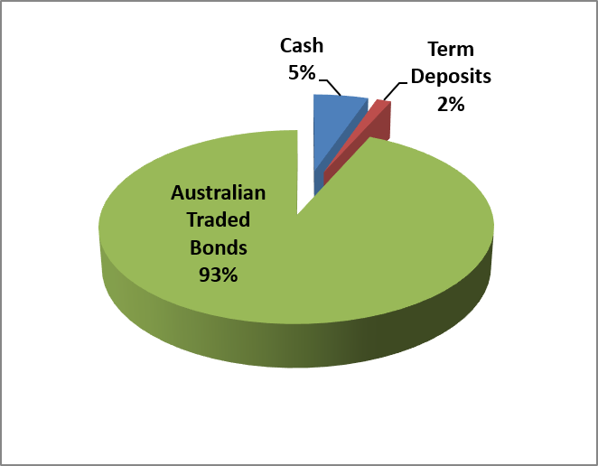

Sector Exposure

Figure 2. Current CF-2 holdings by sector
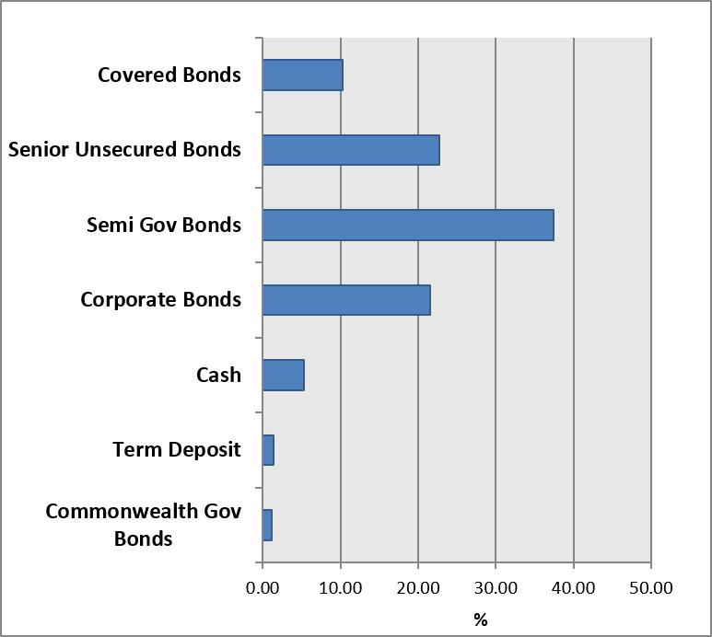
Income & Crediting Rate
Income earned by CF-2 is accrued daily and credited annually to the account of clients (normally on or around 1 June). The crediting rate is determined by the total gross income earned from

CF-2 investments over the preceding 12-month period ending 31 May, less, the partial recoup of office operating costs.
For the 12-month period ending 31 May 2026, the gross return of CF-2 was 4.05%. Following the deduction of office operating costs, an annual crediting rate of 3.20% was declared for clients invested in CF-2 only#, and 3.00% for clients invested in both CF-2 and CF-3# as at 1 June 2025.
An interim rate of 2.00% was credited to the account of clients if their funds were paid out of Court during the year.

Annual Crediting Rate

Figure 3. CF-2 & RBA rates over past 5 years
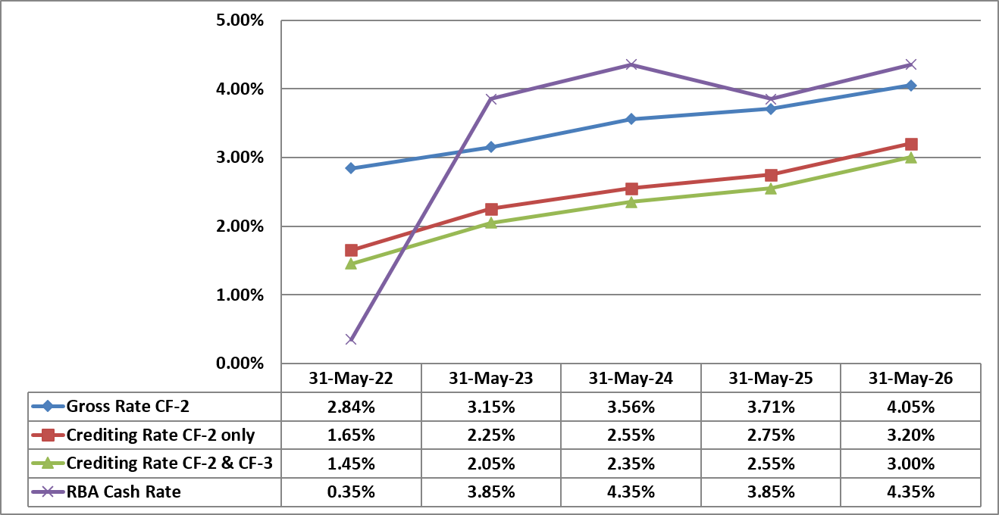
# Since 2011, two separate crediting rates have been declared for CF-2. This means that clients with funds invested in both CF-2 and Common Fund No. 3 (CF-3) are paid a CF-2 crediting rate that is 0.20% p.a. less than the crediting rate declared for clients invested only in CF-2. This approach helps to cover the costs of administering CF-3.

Figure 4. Growth of $10,000 invested and compounded in CF-2 & RBA rates over past 5 years
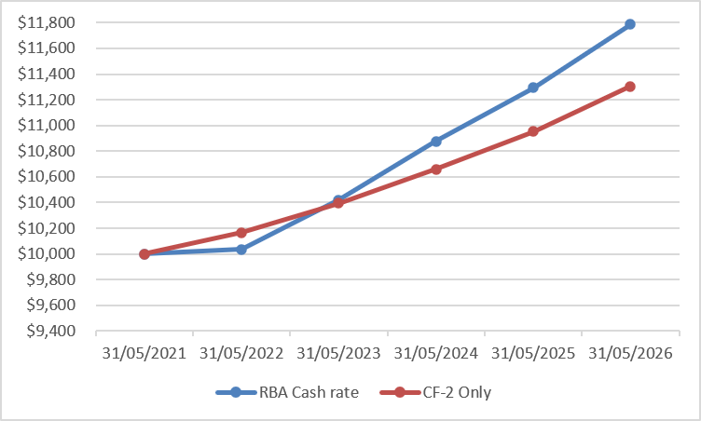

Commentary

The funds’ crediting rates increased by 0.45% compared to the previous twelve months’ rates. The income return generated by the Fund is linked to the official cash rate as set by the Reserve Bank of Australia (RBA) as well as bond yields.

The RBA changed direction in early 2026. After cutting rates down to 3.60% the year before, high inflation figures forced them to raise rates again.

The RBA raised the official interest rate three times in four months. This brought the current rate up to 4.35%. The bank recently decided to keep the rate at this level. The RBA Governor stated that rates will stay high for a while until inflation is under control.

Government bonds became more volatile over the year. The interest yield on a 10-year Australian Government bond jumped from 4.11% up to 5.14%.
This big jump happened because of global events. Conflict in the Middle East caused global oil prices to shoot up by over 50% which forced bond yields to rise quickly.

What does this all mean?

Higher interest rates are now slowing down the economy. Living costs are high, and people are spending less money, and Australian house prices have started to fall.

However, as the job market is still strong, prices for everyday goods are still rising too fast and many experts believe the RBA will keep interest rates exactly where they are for the rest of the year.

The current relatively higher interest rate environment compared to the historic lows of a few years ago continue to provide opportunities to reinvest bonds at more attractive rates, which should be more favourable for future income for the fund.
NEED FURTHER INFORMATION?
For further information on how we manage your funds please visit the FIC website at www.fundsincourt.vic.gov.au or call 1300 039 390 to speak to a member of staff.

Fund Details

Portfolio Statistics
Market Value | $1,022m
Number of Holdings | 103
Portfolio Duration | 4.39 years
Market Yield | 5.12%

Top 10 Holdings (Market Value) excl. Cash  (Coupon, Maturity) | %
NSWTC Semi Gov (3.00%, 20 Feb 2030) | 5.15
WBC Covered Bond PP (3.05%, 5 April 2034) | 4.23
WBC Covered Bond PP (2.95%, 16 May 2034) | 4.17
TCV Semi Gov (5.50%, 15 Sept 2039) | 3.90
SAFA Semi Gov (2.75%, 24 May 2030) | 3.57
NSWTC Semi Gov (5.25%, 22 Feb 2039) | 3.38
NAB MTN (4.85%, 22 Mar 2029) | 3.07
QTC Semi Gov (5.25%, 13 Aug 2038) | 2.43
TCV Semi Gov (1.50%, 10 Sept 2031) | 2.34
WBC MTN (4.30%, 19 June 2030) | 2.29

Holdings by Long Term Credit Rating  (excl. Cash & Term Deposits < 1 year) | %
AAA | 12.7
AA+ | 26.8
AA | 10.2
AA- | 27.6
A+ | 12.2
A | 2.9
A- | 4.4
BBB+ | 1.9
BBB | 1.3

Maturity Profile | %
0 – 1 year | 12.8
1 – 3 year | 17.8
3 – 5 year | 28.1
5 – 10 year | 20.6
10+ years | 20.7

