**Fund Overview**

**Funds in Court**

Common Fund No. 3

Annual Fact Sheet – 30 June 2025

Common Fund No. 3 (CF-3) provides clients with the potential to achieve capital growth over the long term. The Fund invests in a portfolio of publicly listed Australian shares, whilst a small percentage of the Fund is also invested in cash, all held in the name of the Senior Master.

CF-3 operates as a unit trust structure. This means that each client’s investment in CF-3 is determined via the issue of a number of “units” in the Fund, rather than directly owning individual shares. The “unit holding” and the “unit price” (which reflects the value of the underlying shares in the portfolio) is used to calculate the value of each client’s investment in CF-3.

Due to the volatile nature of the share market the “unit price” may rise or fall on a daily basis.

**Investment Approach**

CF-3 is actively managed relative to the benchmark but with generally low portfolio turnover. The Fund will typically hold between 20 and 25 shares and mainly invests in large capitalisation shares (commonly referred to as “blue chip” shares) across a range of industry sectors. The Senior Master is responsible for all investment decisions.

**Figure 1. An initial investment of $10,000 in 2004 would have grown to $54,812 today if distributions were reinvested**

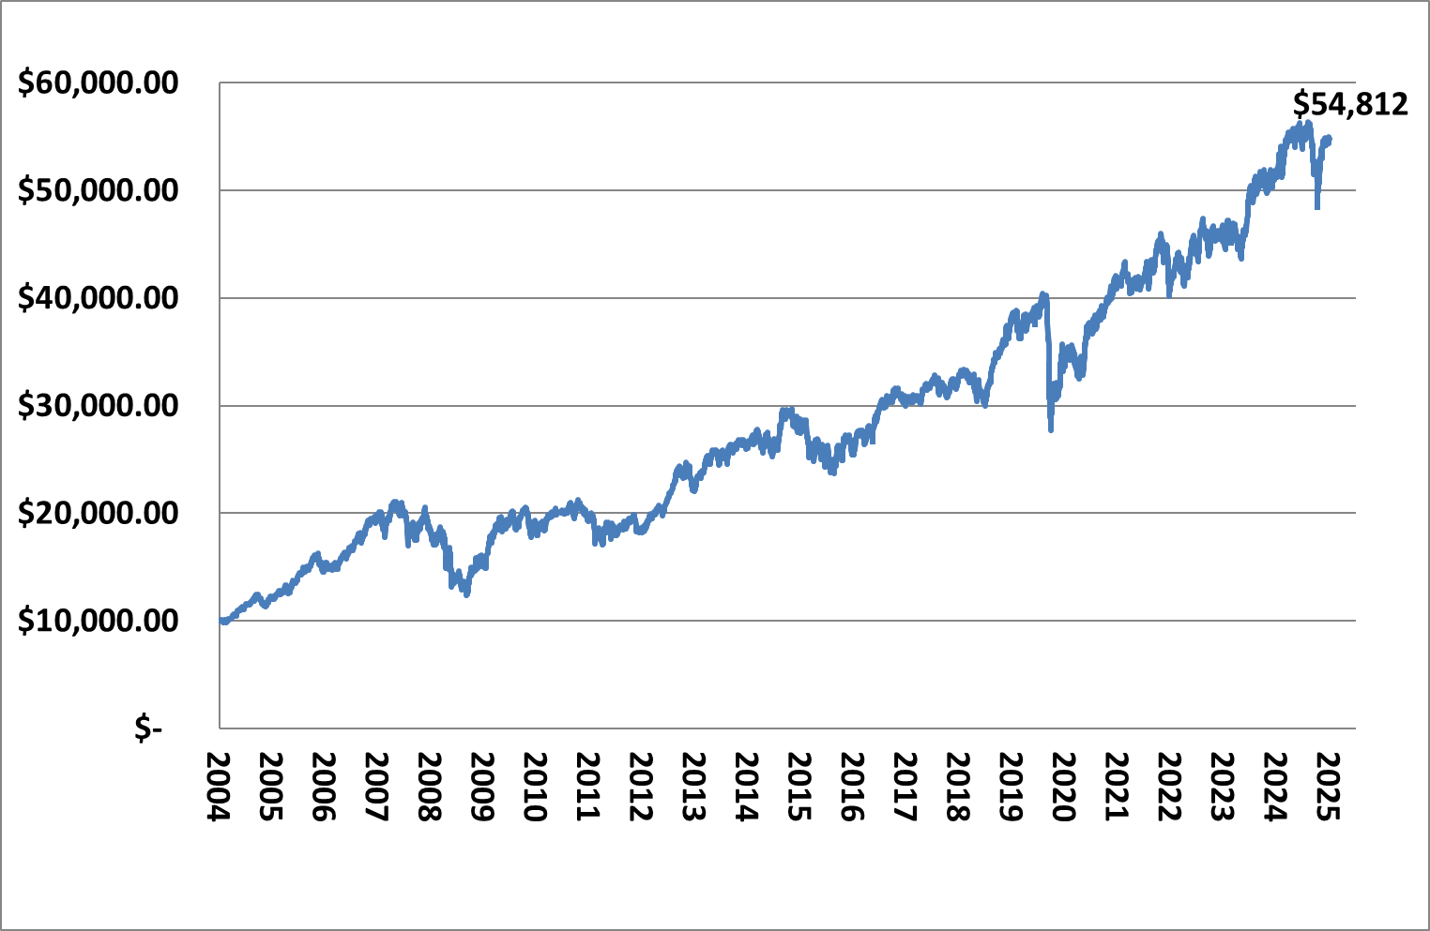

**Fund Details**

|  |  |
| --- | --- |
| **Fund Objective** | To provide capital growth and income (via distribution of dividends) over an investment timeframe of at least 6 years. |
| **Performance Benchmark** | S&P/ASX 50 Accumulation Index |
| **Fund Size** | $827.9 million |
| **Inception Date** | 1 July 2004 |
| **No. of Stocks** | 20 |
| **Income Distribution** | Monthly (if applicable) |
| **Unit Pricing** | Daily |
| **Unit Price** | $1.9416 |
| **Management Costs** | No direct fees are charged for the management of CF-3. However, as part of the Funds in Court cost recovery process, clients with an allocation to both CF-3 and Common Fund No. 2 (CF-2) will be credited with a CF-2 annual crediting rate, that is, 0.20% less than the crediting rate for clients with an allocation to CF-2 only. |

**PLEASE NOTE:**

**For further information on the investment risks associated with CF-3 and how FIC seeks to minimise these risks, please refer to the relevant Information Guide on our website at www.fundsincourt.vic.gov.au**

**Total Return**

|  |  |  |  |  |  |  |  |  |
| --- | --- | --- | --- | --- | --- | --- | --- | --- |
| **As at  30 June 2025** | **Qtr  %** | **1 Yr %** | **3 Yr  % p.a.** | **5 Yr  % p.a.** | **7 Yr  % p.a.** | **10 Yr % p.a.** | **Since Inc. # % p.a.** | **Since Dec. 92*  % p.a.** |
| CF-3 | 6.3 | 6.6 | 9.8 | 9.9 | 7.6 | 7.1 | 8.4 | 10.0 |
| S&P/ASX 50 | 9.5 | 13.5 | 13.8 | 12.2 | 9.1 | 8.6 | 8.9 | 9.8 |
| Difference | -3.2 | -6.9 | -4.0 | -2.3 | -1.5 | -1.5 | -0.5 | 0.2 |
| CF-3 including franking | 6.5 | 7.5 | 10.9 | 11.3 | 9.0 | 8.5 | 10.1 | - |

*# CF-3 commenced on 1 July 2004.*

*\* The Senior Master first purchased equities directly for beneficiaries on 21 December 1992.*

*Past performance is not a reliable indicator of future performance.*

**Commentary**

The portfolio delivered a total return of 6.6% for the 12 month period ending 30 June 2025, underperforming the benchmark S&P/ASX 50 Index. There were noticeable differences in industry sector performance over the financial year, with a range of information technology, communication services and industrial companies posting solid gains that offset falls in the share prices of companies exposed to the energy, consumer staples and health care sectors. With regards to relative portfolio performance against the benchmark, the main detractors were the overweight holdings in IDP Education Limited and CSL Ltd and the underweight holding in Wesfarmers Limited, while the main contributors were the overweight holdings in Computershare Ltd, Resmed Inc and Fisher & Paykel Healthcare.

The Australian share market had a strong return over the financial year, as economic growth and corporate earnings remained solid, inflationary pressures eased and central banks began reducing interest rates. There were however volatile periods within the financial year. Very strong gains were made during the first part of the financial year to mid-February 2025 as positive market sentiment came mainly from interest rate cuts

from the U.S. central bank, falling inflation, stimulus measures in China and an initial positive reaction to the U.S. election outcome. There was increased volatility and sharp market declines from mid-February 2025 to mid-April 2025 as caution grew, driven largely by rising trade tensions sparked by tariff announcements from the U.S., signals from the U.S. central bank of a slower intended pace of rate cuts and shifting geopolitical landscapes in Europe and the Middle East. The market recovered strongly from the mid-April 2025 lows to the end of the financial year as sentiment improved mainly from easing trade tensions stemming from announcements of a pause in U.S. tariffs and trade negotiations proceeding.

**Figure 2. S&P/ASX 50 index chart showing performance for financial year 2024/2025**

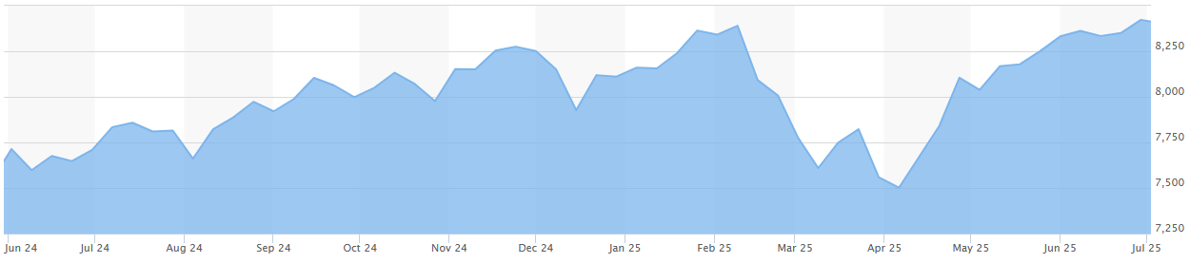

**Holdings**

|  |  |
| --- | --- |
| **COMPANY NAME** | **%** |
| COMMONWEALTH BANK OF AUSTRALIA | 12.96 |
| CSL LIMITED | 10.40 |
| BHP GROUP LTD | 9.63 |
| MACQUARIE GROUP | 9.01 |
| GOODMAN GROUP | 8.14 |
| NATIONAL AUSTRALIA BANK | 5.58 |
| COMPUTERSHARE | 4.92 |
| RESMED INC | 4.40 |
| WESTPAC BANKING CORPORATION | 4.02 |
| SANTOS LIMITED | 3.70 |
| TELSTRA | 3.46 |
| FISHER & PAYKEL HEALTHCARE | 3.29 |
| SEEK LIMITED | 3.23 |
| WOOLWORTHS GROUP | 2.91 |
| RIO TINTO | 2.88 |
| CASH | 2.66 |
| TRANSURBAN GROUP | 2.33 |
| AUSTRALIA & NEW ZEALAND BANK | 2.12 |
| ORIGIN ENERGY | 1.98 |
| IDP EDUCATION | 1.26 |
| WOODSIDE ENERGY | 1.12 |

**Portfolio Activity**

Portfolio turnover has remained relatively low over the last 12 months which is consistent with the long-term investment approach of the Fund.

The main portfolio changes implemented over the 2024/2025 financial year were the purchase of a new holding in Origin Energy Limited, which is a leader in energy exploration, production, power generation and retailing. Additional purchases in existing holdings were also made in Macquarie Group, Goodman Group and IDP Education. The purchase of these new and additional holdings were mainly funded by selling the total amount of holdings in James Hardie Industries Inc and partially selling down some existing holdings in Fisher Paykel Healthcare and CBA.

**NEED FURTHER INFORMATION?**

**For further information on how we manage your funds please visit the FIC website at** [**www.fundsincourt.vic.gov.au**](http://www.fundsincourt.vic.gov.au) **or call**

**1300 039 390.**

**Sector Exposure**

The sector exposure of the Fund has not changed significantly since the previous year. CF‑3 continues to invest heavily in financials, health care and materials.

**Figure 3. Current CF-3 Investments by Sector**

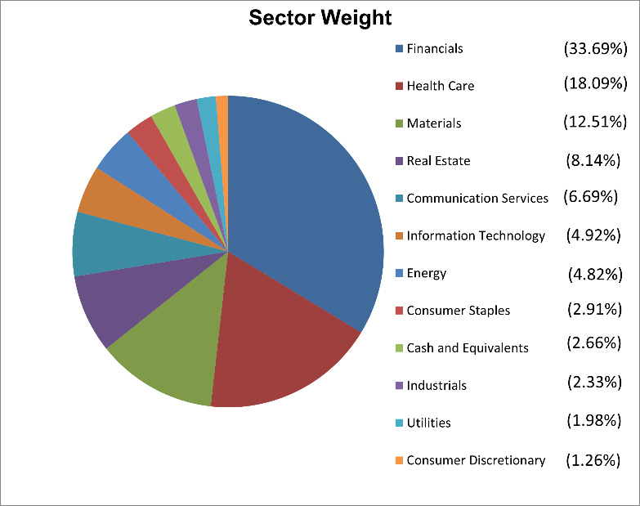

**Distribution History**

The investment earnings of CF-3 are distributed to unitholders on a monthly basis where applicable. The investment earnings may include cash income, dividend income, and realised capital gains. A summary of the total cents per unit distribution made from CF-3 for each of the last five financial years is provided below. The 2021/2022 distribution was greater than that of other years as a result of distributing the realised capital gains generated as part of a portfolio review and the BHP Petroleum merger with Woodside.

|  |  |
| --- | --- |
| **Financial Year** | **Cents per unit** |
| 2020/2021 | 6.0 |
| 2021/2022 | 18.9 |
| 2022/2023 | 8.6 |
| 2023/2024 | 11.4 |
| 2024/2025 | 8.3 |