Fund Overview

Funds in Court

Common Fund No. 3

Quarterly Fact Sheet – 30 September 2023

Common Fund No. 3 [CF-3] provides beneficiaries with the potential to achieve capital growth over the long term. The Fund invests in a portfolio of publicly listed Australian shares, whilst a small percentage of the Fund is also invested in cash.
CF-3 operates as a unit trust structure. This means that each beneficiary’s investment in CF-3 is determined via the issue of a number of “units” in the Fund, rather than directly owning individual shares. The “unit holding” and the “unit price”, (which reflects the value of the underlying shares in the portfolio), is used to calculate the value of each beneficiary’s investment in CF-3.

Due to the volatile nature of the share market the “unit price” may rise or fall on a daily basis.

Investment Approach

CF-3 is actively managed relative to the benchmark but with low portfolio turnover. The Fund primarily invests in large capitalisation shares (commonly referred to as “blue chip” shares) across a range of industry sectors.

Figure 1. An initial investment of $10,000 in 2004 would have grown to $45,215 today if distributions were reinvested
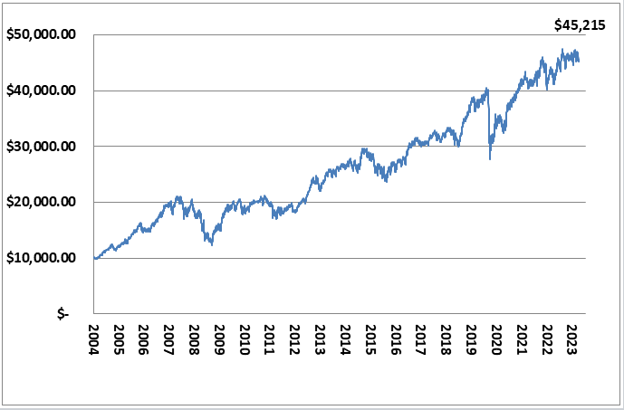
Fund Details
Fund Objective: | To provide capital growth and income (via distribution of dividends) over an investment timeframe of at least 6 years.
Performance Benchmark | S&P/ ASX 50 Accumulation Index
Fund Size: | $727.6 million
Inception Date: | 1 July 2004
No. of Stocks: | 21
Income Distribution: | Monthly (if applicable)
Unit Pricing: | Daily
Unit Price: | $1.7668
Management Costs: | No direct fees are charged for the management of CF-3. However, as part of the Funds in Court cost recovery process, beneficiaries with an allocation to both CF-3 and Common Fund No. 2 [CF-2] will be credited with a CF-2 annual crediting rate, that is, 0.20% less than the crediting rate for beneficiaries with an allocation to CF-2 only.
PLEASE NOTE:
For further information on the investment risks associated with CF-3 and how FIC seeks to minimise these risks, please refer to the relevant Information Guide on our website at www.fundsincourt.vic.gov.au

Total Return

As at  30 September 2023 | Qtr  % | 1 Yr  % | 3 Yr  % p.a. | 5 Yr  % p.a. | 7 Yr  % p.a. | 10 Yr  % p.a. | Since Inc.^  % p.a.
CF-3 | -1.2 | 9.9 | 11.3 | 6.6 | 7.3 | 6.2 | 8.2
S&P/ASX 50 | -0.6 | 14.2 | 12.0 | 7.1 | 8.2 | 7.2 | 8.3
Difference | -0.6 | -4.3 | -0.7 | -0.5 | -0.9 | -1.0 | -0.1
CF-3 Including Franking | -0.8 | 11.1 | 13.0 | 8.3 | 9.1 | 7.9 | 9.9
^ CF-3 commenced on 1 July 2004.
Past performance is not a reliable indicator of future performance.

Holdings

COMPANY NAME | %
BHP GROUP LTD | 13.19
CSL LIMITED | 12.39
COMMONWEALTH BANK OF AUSTRALIA | 9.25
WOOLWORTHS GROUP | 6.00
MACQUARIE GROUP | 5.23
JAMES HARDIE INDUSTRIES | 5.14
NATIONAL AUSTRALIA BANK | 4.69
TELSTRA | 4.57
TRANSURBAN GROUP | 4.43
SANTOS LIMITED | 4.35
GOODMAN GROUP | 4.26
COMPUTERSHARE | 3.64
RIO TINTO | 3.47
CASH | 3.12
SEEK LIMITED | 3.07
WESTPAC BANKING CORPORATION | 2.86
AMCOR PLC | 2.41
AUSTRALIA & NEW ZEALAND BANK | 2.12
FISHER & PAYKEL HEALTHCARE | 2.06
WOODSIDE ENERGY | 1.97
ASX LTD | 0.93
LENDLEASE GROUP | 0.85
NEED FURTHER INFORMATION?

For further information on how we manage your funds please visit the FIC website at www.fundsincourt.vic.gov.au or call
1300 039 390.
Sector Exposure
The sector exposure of the Fund has not changed significantly since the previous quarter. CF-3 continues to invest heavily in financials and materials.

Figure 2. Current CF-3 Investments by Sector
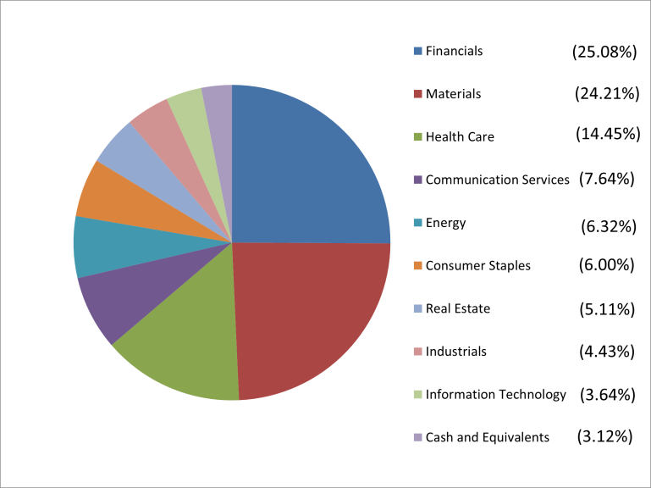
Portfolio Activity

During the September 2023 quarter, the Fund established a new holding in Fisher & Paykel Healthcare Corporation Limited, which is a world leader in medical devices and systems for use in respiratory care, acute care, surgery and in the treatment of obstructive sleep apnea. The Fund also added to the existing holding in Goodman Group. The purchases of these holdings were funded by selling the total amount of holdings in Coles Group Ltd.

