Fund Overview

Funds in Court

Common Fund No. 3

Annual Information Sheet – 30 June 2026

Common Fund No. 3 [CF-3] provides clients with the potential to achieve capital growth over the long term. The Fund invests in a portfolio of publicly listed Australian shares, whilst a small percentage of the Fund is also invested in cash, all held in the name of the Senior Master.
CF-3 operates as a unit trust structure. This means that each client’s investment in CF-3 is determined via the issue of a number of “units” in the Fund, rather than directly owning individual shares. The “unit holding” and the “unit price”, (which reflects the value of the underlying shares in the portfolio), is used to calculate the value of each client’s investment in CF-3.

Due to the volatile nature of the share market the “unit price” may rise or fall on a daily basis.

Investment Approach

CF-3 is actively managed relative to the benchmark but with generally low portfolio turnover. The Fund will typically hold between 20 and 25 shares and mainly invests in large capitalisation shares (commonly referred to as “blue chip” shares) across a range of industry sectors. The Senior Master is responsible for all investment decisions.

Figure 1. An initial investment of $10,000 in 2004 would have grown to $55,611 today if distributions were reinvested
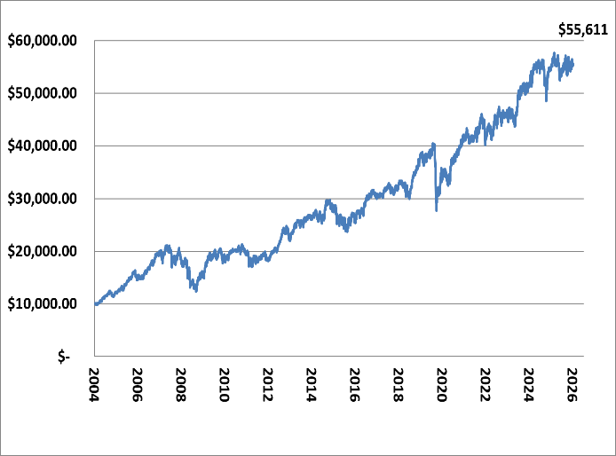
Fund Details
Fund Objective: | To provide capital growth and income (via distribution of dividends) over an investment timeframe of at least 6 years.
Performance Benchmark | S&P/ ASX 50 Accumulation Index
Fund Size: | $857.8 million
Inception Date: | 1 July 2004
No. of Stocks: | 22
Income Distribution: | Monthly (if applicable)
Unit Pricing: | Daily
Unit Price: | $1.9092
Management Costs: | No direct fees are charged for the management of CF-3. However, as part of the Funds in Court cost recovery process, clients with an allocation to both CF-3 and Common Fund No. 2 [CF-2] will be credited with a CF-2 annual crediting rate, that is, 0.20% less than the crediting rate for clients with an allocation to CF-2 only.
PLEASE NOTE:
For further information on the investment risks associated with CF-3 and how FIC seeks to minimise these risks, please refer to the relevant Information Guide on our website at www.fundsincourt.vic.gov.au

Total Return

As at  30 June 2026 | Qtr  % | 1 Yr  % | 3 Yr  % p.a. | 5 Yr  % p.a. | 7 Yr  % p.a. | 10 Yr  % p.a. | Since Inc. #  % p.a. | Since Dec. 92*  % p.a.
CF-3 | 3.0 | 0.9 | 6.5 | 5.9 | 5.5 | 7.8 | 8.1 | 9.7
S&P/ASX 50 | 4.0 | 5.9 | 10.8 | 8.3 | 8.0 | 9.6 | 8.7 | 9.7
Difference | -1.0 | -5.0 | -4.3 | -2.4 | -2.5 | -1.8 | -0.6 | 0.0
CF-3 including franking | 3.1 | 1.9 | 7.5 | 7.2 | 6.9 | 9.3 | 9.7 | -

# CF-3 commenced on 1 July 2004.
* The Senior Master first purchased equities directly for clients on 21 December 1992.
Past performance is not a reliable indicator of future performance.

Commentary

The portfolio delivered a total return of 0.9% for the 12-month period ending 30 June 2026, underperforming the benchmark S&P/ASX 50 Index. There were noticeable differences in industry sector performance over the financial year, with a range of materials, consumer staples and energy companies posting solid gains that offset falls in the share prices of companies exposed to the information technology and health care sectors. With regards to relative portfolio performance against the benchmark, the main detractors were the overweight holdings in CSL Limited, Seek Ltd and Resmed Inc, while the main contributors were not holding XERO Ltd and Wisetech Global Ltd and the overweight holding in Rio Tinto Ltd.

The Australian share market delivered a modest return over the financial year, with investors navigating inflation concerns, changing interest rates and ongoing geopolitical uncertainty.
Market conditions were favourable between July 2025 and October 2025, supported by lower interest rates and progress in negotiations surrounding U.S. tariffs. Investor confidence weakened in November 2025 as concerns over inflation emerged, leading to a period of market volatility.

However, supportive commentary from the Reserve Bank of Australia (RBA) helped improve sentiment, contributing to a recovery that saw the market reach record highs by February 2026.
Inflationary pressures re-emerged throughout 2026, driven by continued investment in data centres and escalating tensions in the Middle East. Sharp movements in oil prices added to market volatility and weighed on investor confidence. In response to rising inflation, the RBA increased interest rates three times during the year. Conditions improved towards the end of the financial year as oil prices eased from their highs and diplomatic efforts in the Middle East helped reduce concerns about disruptions to global trade.

Figure 2. S&P/ASX 50 index chart showing performance for financial year 2025/2026
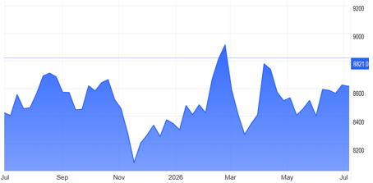
Holdings

COMPANY NAME | %
BHP GROUP LTD | 15.02
COMMONWEALTH BANK OF AUSTRALIA | 10.13
MACQUARIE GROUP | 9.52
GOODMAN GROUP | 7.14
NATIONAL AUSTRALIA BANK | 6.05
CASH | 4.66
COMPUTERSHARE | 4.56
RIO TINTO | 4.47
CSL LIMITED | 4.33
WOOLWORTHS GROUP | 3.62
SANTOS LIMITED | 3.37
WESTPAC BANKING CORPORATION | 3.16
RESMED INC | 3.11
FISHER & PAYKEL HEALTHCARE | 3.03
TELSTRA | 3.00
AUSTRALIA & NEW ZEALAND BANK | 2.48
WOODSIDE ENERGY | 2.39
TRANSURBAN GROUP | 2.31
REA GROUP | 2.13
SEEK LIMITED | 2.03
ORIGIN ENERGY | 1.95
CLEANAWAY WASTE MANAGEMENT | 0.82
IDP EDUCATION | 0.72

Portfolio Activity

Portfolio turnover has remained relatively low over the last 12 months which is consistent with the long-term investment approach of the Fund.

The main portfolio changes implemented over the 2025/2026 financial year were the purchases of new holdings in REA Group Limited, which is a leading global digital business specializing in property, and Cleanaway Waste Management Limited, which is a leading Australian waste management and resource recovery company.

NEED FURTHER INFORMATION?

For further information on how we manage your funds please visit the FIC website at www.fundsincourt.vic.gov.au or call
1300 039 390.
Sector Exposure
The sector exposure of the Fund has not changed significantly since the previous year. CF-3 continues to invest heavily in financials, materials and health care.

Figure 3. Current CF-3 Investments by Sector
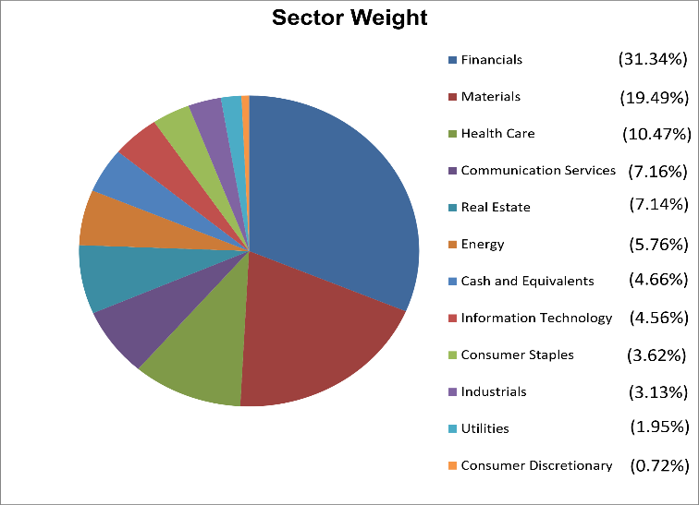

Distribution History

The investment earnings of CF-3 are distributed to unitholders on a monthly basis where applicable. The investment earnings may include cash income, dividend income, and realised capital gains. A summary of the total cents per unit distribution made from CF-3 for each of the last five financial years is provided below. The 2021/2022 distribution was greater than that of other years as a result of distributing the realised capital gains generated as part of a portfolio review and the BHP Petroleum merger with Woodside.
Financial Year | Cents per unit
2021/ 2022 | 18.9
2022/ 2023 | 8.6
2023/ 2024 | 11.4
2024/ 2025 | 8.3
2025/ 2026 | 6.0

