Fund Overview

Funds in Court

Common Fund No. 3

Quarterly Fact Sheet – 30 September 2024

Common Fund No. 3 (CF-3) provides clients with the potential to achieve capital growth over the long term. The Fund invests in a portfolio of publicly listed Australian shares, whilst a small percentage of the Fund is also invested in cash, all held in the name of the Senior Master.
CF-3 operates as a unit trust structure. This means that each client’s investment in CF-3 is determined via the issue of a number of “units” in the Fund, rather than directly owning individual shares. The “unit holding” and the “unit price”, (which reflects the value of the underlying shares in the portfolio), is used to calculate the value of each client’s investment in CF-3.

Due to the volatile nature of the share market the “unit price” may rise or fall on a daily basis.

Investment Approach

CF-3 is actively managed relative to the benchmark but with low portfolio turnover. The Fund primarily invests in large capitalisation shares (commonly referred to as “blue chip” shares) across a range of industry sectors. The Senior Master is responsible for all investment decisions.

Figure 1. An initial investment of $10,000 in 2004 would have grown to $54,978 today if distributions were reinvested
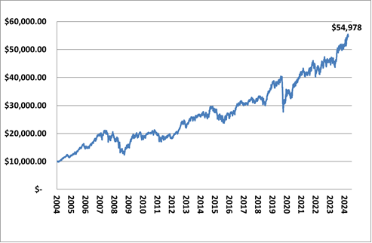
Fund Details
Fund Objective | To provide capital growth and income (via distribution of dividends) over an investment timeframe of at least 6 years.
Performance Benchmark | S&P/ ASX 50 Accumulation Index
Fund Size | $843.0 million
Inception Date | 1 July 2004
No. of Stocks | 20
Income Distribution | Monthly (if applicable)
Unit Pricing | Daily
Unit Price | $2.0240
Management Costs | No direct fees are charged for the management of CF-3. However, as part of the Funds in Court cost recovery process, clients with an allocation to both CF-3 and Common Fund No. 2 (CF-2) will be credited with a CF-2 annual crediting rate, that is, 0.20% less than the crediting rate for clients with an allocation to CF-2 only.
PLEASE NOTE:
For further information on the investment risks associated with CF-3 and how FIC seeks to minimise these risks, please refer to the relevant Information Guide on our website at www.fundsincourt.vic.gov.au

Total Return

As at  30 September 2024 | Qtr  % | 1 Yr  % | 3 Yr  % p.a. | 5 Yr  % p.a. | 7 Yr  % p.a. | 10 Yr  % p.a. | Since Inc.^  % p.a.
CF-3 | 7.2 | 22.1 | 9.9 | 7.6 | 8.9 | 7.7 | 8.8
S&P/ASX 50 | 7.7 | 22.6 | 9.7 | 8.4 | 10.0 | 8.7 | 8.9
Difference | -0.5 | -0.5 | 0.2 | -0.8 | -1.1 | -1.0 | -0.1
CF-3 Including Franking | 7.6 | 23.1 | 11.4 | 9.1 | 10.4 | 9.3 | 10.5
^ CF-3 commenced on 1 July 2004.
Past performance is not a reliable indicator of future performance.

Holdings

COMPANY NAME | %
CSL LIMITED | 12.21
BHP GROUP LTD | 11.83
COMMONWEALTH BANK OF AUSTRALIA | 9.33
MACQUARIE GROUP | 7.27
GOODMAN GROUP | 5.55
NATIONAL AUSTRALIA BANK | 5.20
JAMES HARDIE INDUSTRIES | 4.49
WOOLWORTHS GROUP | 4.13
TELSTRA | 3.98
RESMED INC | 3.84
WESTPAC BANKING CORPORATION | 3.70
TRANSURBAN GROUP | 3.47
RIO TINTO | 3.41
SANTOS LIMITED | 3.33
SEEK LIMITED | 3.28
FISHER & PAYKEL HEALTHCARE | 3.09
COMPUTERSHARE | 3.06
IDP EDUCATION | 3.02
CASH | 2.47
AUSTRALIA & NEW ZEALAND BANK | 2.17
WOODSIDE ENERGY | 1.17
NEED FURTHER INFORMATION?

For further information on how we manage your funds please visit the FIC website at www.fundsincourt.vic.gov.au or call
1300 039 390.
Sector Exposure
The sector exposure of the Fund has not changed significantly since the previous quarter. CF-3 continues to invest heavily in financials, materials and health care.

Figure 2. Current CF-3 Investments by Sector
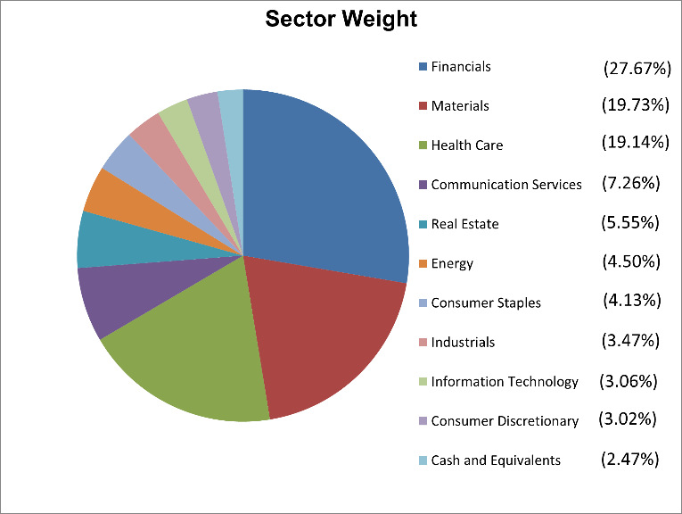

Portfolio Activity

During the September 2024 quarter, the Fund purchased further shares in the existing holdings in Seek Limited and Macquarie Group Limited. The purchase of these holdings was mainly funded by partially selling some of the existing holdings in Fisher & Paykel Healthcare and Commonwealth Bank of Australia.

