funds in court

Corporate governance statement

March 2026
Prepared by John Dennison, Corporate Governance Manager

Contents

Introduction 3
Corporate governance structure 4
Vision, mission and values 5
Organisational structure 6
Chief Executive Officer and Leadership Team 7
Specialist advisory committees 8
External advisory groups and other stakeholders 11
Policies and procedures 13
Risk management 14
Assurance 16
Other important areas 18

Introduction
Funds in Court (FIC) is a discrete division of the Supreme Court of Victoria (the Court). FIC supports the function of the Associate Judge who is the Senior Master. The Senior Master holds, invests and manages funds paid into Court for the benefit of people who are under a legal disability (clients). The Senior Master also manages funds paid into Court pending the outcome of a proceeding, as security for costs, and pursuant to the Trustee Act 1958 (Vic).
The Senior Master is supported by a Judicial Registrar. Both are judicial officers of the Court.
The decisions of the Senior Master and the FIC Judicial Registrar are put into effect by FIC staff. FIC staff work to enhance the lives of clients, ensuring the safe and effective investment of their funds at low cost, and use of their funds in a manner that responds to their diverse needs and aspirations. When dealing with clients or their funds, staff are to act:
- with integrity
- respectfully
- collaboratively; and
- with an acknowledgement of justice to people’s rights
FIC is committed to achieving and demonstrating the highest standards of corporate governance. The FIC governance structure ensures FIC is fully and properly accountable to the Court and its clients for the effective and efficient operation of FIC. The governance arrangements of FIC ensure that:
- the interests of clients are supported and protected
- financial and other risks to the funds administered by FIC are minimised.

FIC has used the Governance Institute of Australia’s ‘Good Governance Guide: Achieving governance in organisations without boards’ to guide the development of FIC’s Corporate Governance Statement.

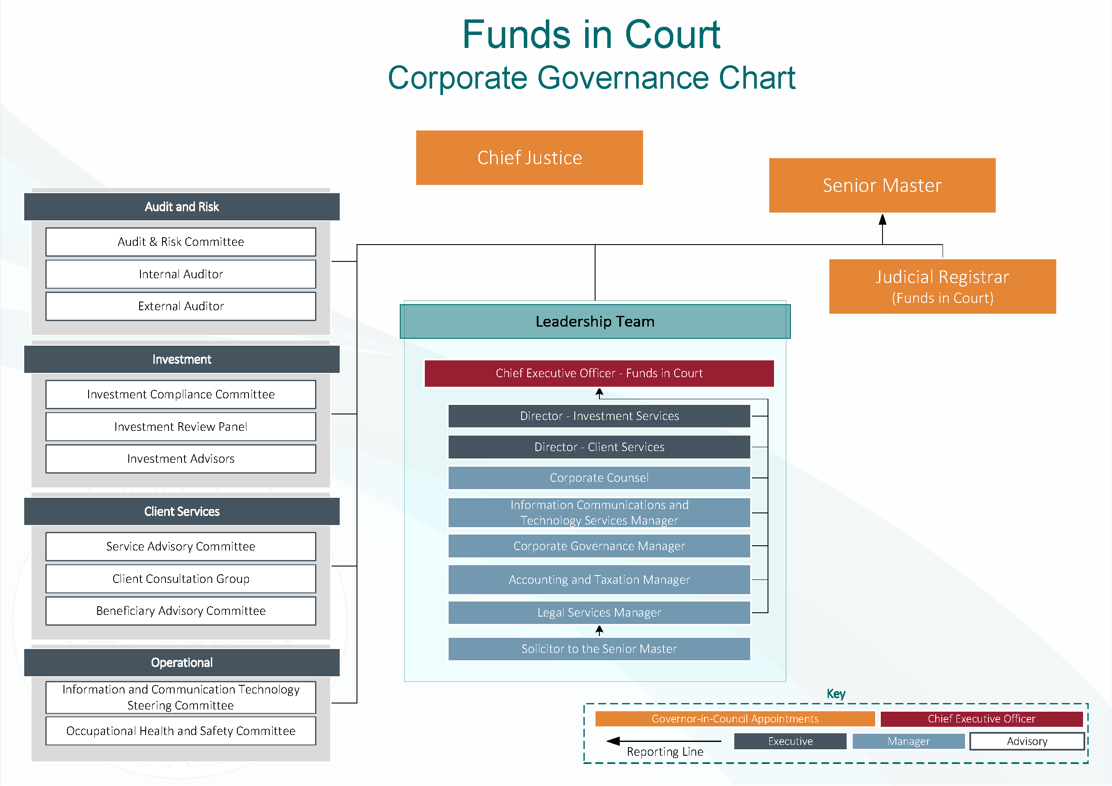
Corporate governance structure

Vision, mission and values

Organisational structure
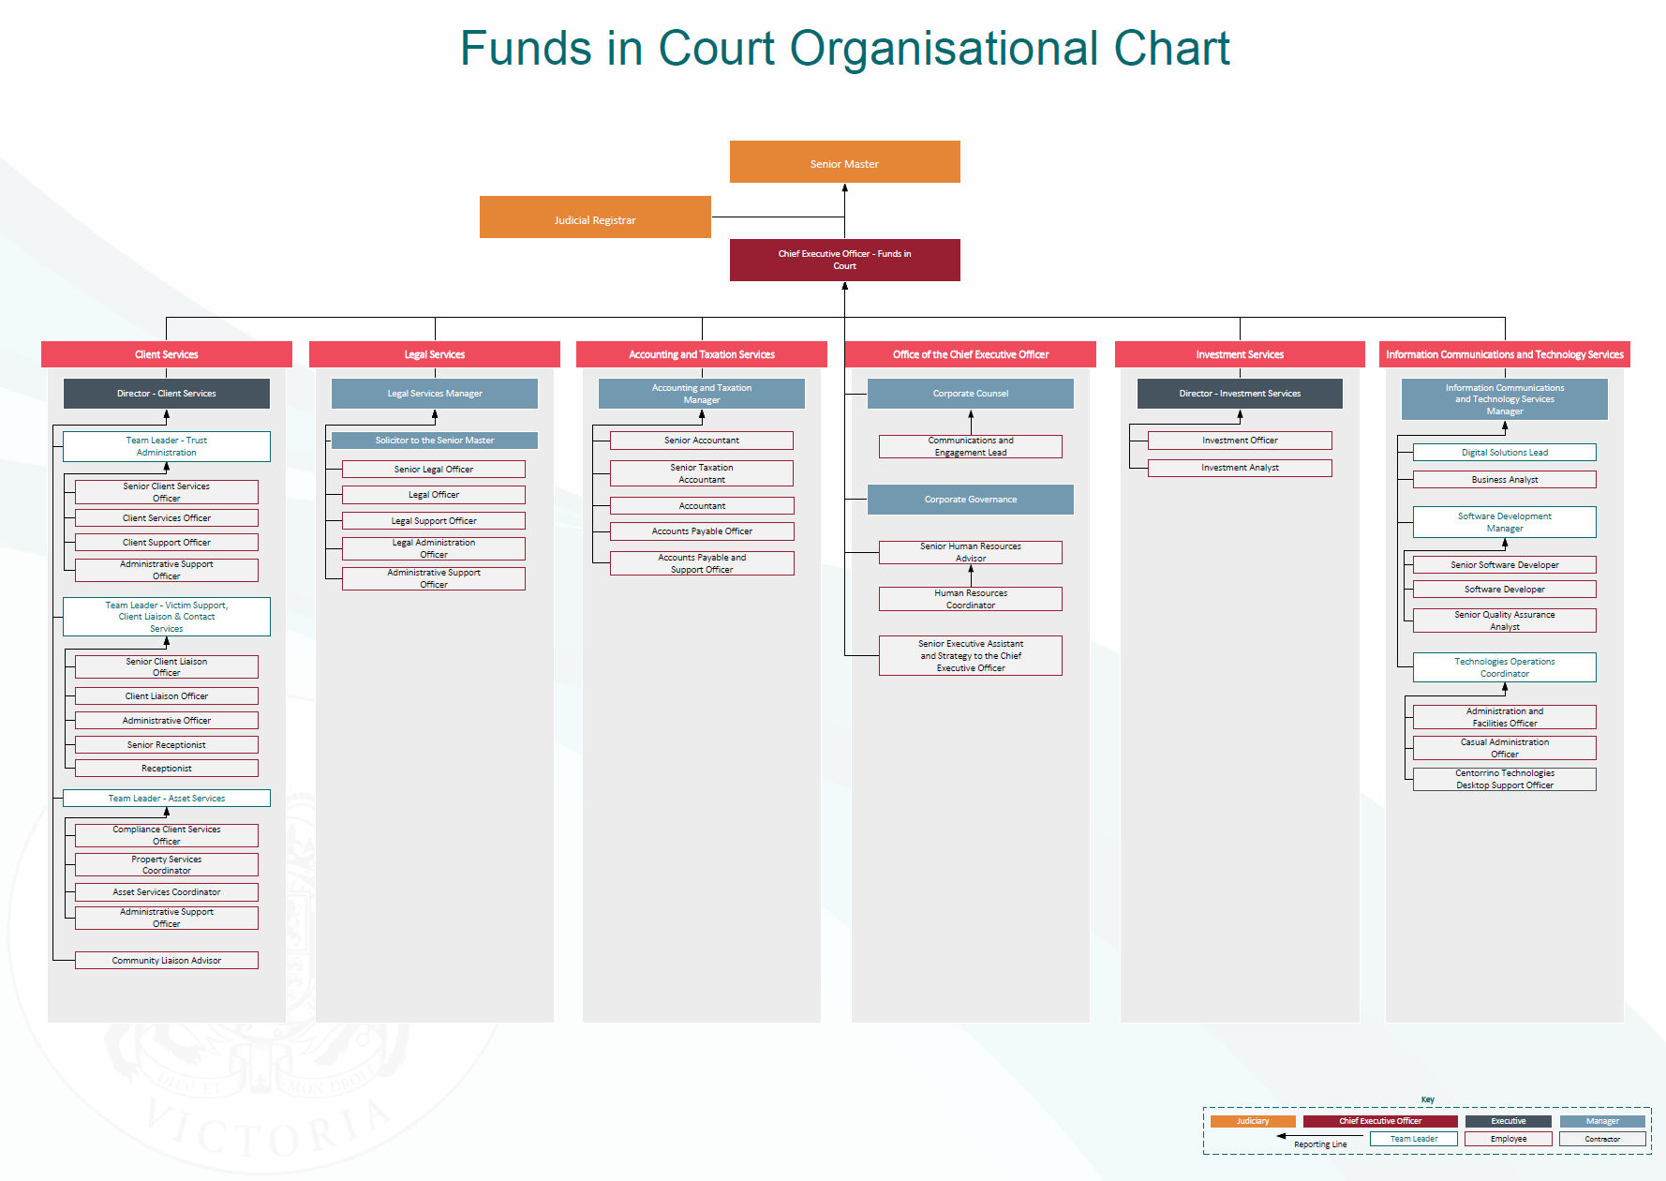

Chief Executive Officer and Leadership Team

Chief Executive Officer - Funds in Court
The role of the Chief Executive Officer - Funds in Court is to:
- set the tone for FIC in conjunction with the Senior Master
- consistently promote FIC’s values and governance principles across the organisation
- provide strategic leadership by driving the implementation of strategic objectives
- monitor performance through regular reporting on key indicators
- proactively manage risk through robust strategies
- support timely operational and financial reporting
- lead, manage, mentor and develop FIC’s Leadership Team.

FIC’s Leadership Team
The composition of the Leadership Team is:
Executive
- Chief Executive Officer - Funds in Court
- Director Client Services
- Director Investment Services

Senior Management
- Corporate Counsel
- Information Communications and Technology Services Manager
- Legal Services Manager
- Accounting and Taxation Manager
- Corporate Governance Manager.

Led by the Chief Executive Officer - Funds in Court the Leadership Team is responsible for delivering FIC’s strategic and operational objectives in line with FIC’s pillars (see Vision, mission and values).

The Leadership Team objectives are to:
- ensure FIC operates effectively and efficiently pursuant to legal and strategic requirements
- drive and maintain FIC culture in line with the FIC Code of Conduct and values
- ensure the interests of the clients are fully supported and protected
- ensure financial and other risks to the funds administered by FIC are minimised
- ensure FIC is fully accountable to clients and other key stakeholders for its proper administration
- ensure FIC is operated in accordance with the strategy, plans and policies approved by the Chief Executive Officer - Funds in Court or the Senior Master.

Specialist advisory committees
The Senior Master has established several specialist advisory committees. These are integral components of FIC's corporate governance structure.
Each Committee has a Charter or Terms of Reference that has been approved by the Senior Master. Each Committee reviews their Charter or Terms of Reference every two years. They contain details including:

- purpose
- objectives
- authority
- membership
- meetings
- duties and responsibilities
- reporting
- administrative arrangements
- conflicts of interest
- induction.

Audit & Risk Committee
Role | Members
The Audit & Risk Committee provides oversight of the following corporate activities and gives advice and makes recommendations to the Senior Master as appropriate, relating to:  - financial reporting  - risk management  - internal controls  - internal and external audit activities  - policies and procedures  - compliance monitoring  - resolution of ethical issues.  The Audit & Risk Committee meets a minimum of four times per year. | The Committee consists of:  - an independent chair  - a minimum of three independent members all with familiarity with general finance and accounting practices. At least one member of the Committee must have accounting, risk management, auditing or related financial management expertise.  Other attendees include:  - the Senior Master  - representatives of the Victorian  Auditor-General  - the internal auditor  - Chief Executive Officer - Funds in Court  - the FIC Judicial Registrar  - Accounting and Taxation Manager  - Corporate Governance Manager.

Investment Review Panel
Role | Members
The Investment Review Panel provides investment recommendations and advice to the Senior Master in light of the investment performance and reports from FIC’s fixed income and equity advisors. The Investment Review Panel focusses on broad policy and investment issues relating to FIC investments as a whole. It does not look at the details of individual clients.  The Investment Review Panel meets a minimum of four times per year. | The Panel consists of:  - a minimum of three independent members with relevant investment experience and expertise, including the external investment advisor retained by FIC  - the Senior Master (Chair)  - Director Investment Services.  Other attendees include:  - Chief Executive Officer - Funds in Court  - Senior Master’s Asset Consultant  - FIC Investment Services Team  - JANA (Senior Master’s Asset Consultants).

Investment Compliance Committee
Role | Members
The Investment Compliance Committee monitors the compliance aspects of the funds managed by the Senior Master. It does this by:  - ensuring investments are made in accordance with the FIC Asset Management Policy  - overseeing and appraising the quality and adequacy of the funds’ investment compliance management  The Investment Compliance Committee meets a minimum of two times per financial year. | The Committee consists of two independent members with relevant investment and compliance experience and expertise and Director Investment Services.  Other attendees include:  - Chief Executive Officer - Funds in Court  - members of the FIC Investment Services team.

Service Advisory Committee
Role | Members
The Service Advisory Committee provides advice and recommendations to the Senior Master on matters including:  - innovative and contemporary service delivery to clients and their caregivers  - effective communication strategies for clients, their caregivers and family members  - effective and appropriate client service standard goals  - effective and appropriate engagement with people who have lived experience to obtain feedback and perspectives on FIC services and processes  - relevant developments in the disability and trustee sectors and changing community expectations.  The Service Advisory Committee meets a minimum of four times per year. | The committee consists of a minimum of four independent members, including the Chair. These members are from:  - the Victorian judiciary  - the Victorian legal profession  - academia  - the disability sector.  The following have a standing invitation:  - the Senior Master  - the FIC Judicial Registrar  - Chief Executive Officer - Funds in Court  - Director Client Services  - Solicitor to the Senior Master  - Community Liaison Advisor.

Information and Communication Technology Steering Committee
Role | Members
The Information and Communication Technology Steering Committee assists the Senior Master in fulfilling their oversight responsibilities regarding the overall role of information technology and digital information underpinning FIC’s business strategy. This includes:  - technology-related investments, operations, strategies of FIC and their alignment with the FIC's overall business strategy and objectives  - FIC's technology risk management and security framework and its effectiveness (in conjunction with the Audit & Risk Committee).  The Information and Communication Technology Steering Committee meets a minimum of four times per year. | The Committee consists of:  - a minimum of two independent members with relevant expertise and experience  - Chief Executive Officer - Funds in Court (Chair)  - Information Communications and Technology Services Manager  - Director Investment Services  - Corporate Governance Manager.

Occupational Health & Safety Committee
FIC’s Occupational Health & Safety Committee operates as a sub-committee of the Court’s Occupational Health & Safety Committee and in accordance with the Court’s Occupational Health & Safety Committee Terms of Reference.
Role | Members
The FIC Occupational Health & Safety Committee provides a mechanism for consultation and co-operation between the Senior Master, Leadership Team and staff members with relevant roles for health, safety and wellbeing matters.  The FIC Occupational Health & Safety Committee meets four times per year or as otherwise scheduled. | The FIC Occupational Health & Safety Committee consists of:  - a nominated management representative (Chair and Secretary)  - Senior Human Resources Advisor  - two elected Health & Safety Representatives  - a representative from the Information Communications and Technology Services - Facilities team.

External advisory groups and other stakeholders
FIC is committed to consulting with key stakeholders to ensure that they understand FIC’s objectives and strategies and to proactively gather advice and recommendations to assist the Senior Master and FIC staff in achieving those objectives.

Beneficiary Advisory Committee
Role | Members
Beneficiary Advisory Committee meetings facilitate the flow of information and ideas between FIC and key stakeholders.  The Beneficiary Advisory Committee meets four times per year. | The Committee is comprised of:  - the Senior Master (Chair)  - selected senior FIC staff  - parents and carers of clients  - representatives of:  - the Victorian legal profession  - the Transport Accident Commission.

Client Consultation Group
Role | Members
The Client Consultation Group is a group of clients who consult with FIC’s Community Liaison Advisor on a wide range of topics that affect clients.  A summary of the discussion is provided to the Leadership Team and the Service Advisory Committee.  The Client Consultation Group meets four to six times per year. | The Client Consultation Group consists of:  - interested clients  - FIC’s Community Liaison Advisor  - relevant FIC staff.

Client satisfaction surveys
FIC undertakes a client satisfaction survey every three years via an independent research agency.
Clients and caregivers of clients are encouraged to complete as much of the survey as they can. All survey responses are anonymous. Their feedback helps FIC improve its services and communication with clients.
For more information about client satisfaction surveys, visit the Reports page of the FIC website.

SPECIFIC PROCESS SURVEYS
FIC also contacts clients who have recently completed a specific process to gather their feedback. Surveys are sent out to clients after they have:
- bought a motor vehicle
- modified, renovated or built a house
- had their funds paid out to them.
FIC’s Community Liaison Advisor analyses these results, identifies consistent pain points and reports on the survey results to the Leadership Team for discussion. The relevant managers develop improvements to address themes that have emerged from the survey results. The improvements and their impact are reported on and discussed at subsequent meetings with all managers, the FIC Judicial Registrar and Senior Master in attendance.

External stakeholders
FIC liaises with many of its key stakeholders, including:
- the legal profession
- Transport Accident Commission
- National Disability Insurance Agency
- Financial Assistance Scheme
- Office of the Public Advocate
- State Trustees Limited.
The Senior Master, Chief Executive Officer - Funds in Court and senior staff schedule and hold information sessions with key stakeholders to facilitate information exchange. Such interactions are important for stakeholders and FIC to better understand each other’s needs and to encourage collaboration and partnerships as appropriate.
Formal management level meetings, either regular or on an ad hoc basis, are also held between FIC management and other key corporate stakeholders.
Relevant outcomes from all meetings with key stakeholders are reported and minuted at Leadership Team meetings.

Policies and procedures

KEY POLICIES AND PROCEDURES

FIC’s policies and procedures are a structured set of principles and rules that provide guidance and standardisation for processes across FIC.

FIC is subject to all the policies and procedures that apply to employees of the Victorian Public Sector and the Supreme Court of Victoria. FIC also has policies and procedures that relate to FIC’s specific operations which are approved by the Senior Master or Chief Executive Officer - Funds in Court. These policies and procedures:
- ensure compliance with laws and regulations
- give guidance for decision-making
- define internal administrative processes.
FIC’s policies and procedures support the Victorian Public Sector Code of Conduct and relate to two key areas: governance and operations.
All policies and procedures are mandatory and are available to staff through the FIC intranet.

Risk management

Risk Management Framework

To achieve governance excellence, FIC has implemented a risk management framework consistent with the Victorian Government Risk Management Framework and has adopted AS/NZS ISO 31000:2018 guidelines. .
The Corporate Governance Manager performs the role of risk management coordinator and is responsible for implementing and maintaining an enterprise risk management model. This model identifies, assesses, mitigates, and monitors risks across the organisation in accordance with AS/NZS ISO 31000:2018.
The FIC risk management model consists of the:
- Risk Profile and Management Plan (Plan)
- Financial Code of Conduct
- Fraud and Corruption Control Plan
- monthly Risk Management Report to the Leadership Team
- quarterly Risk Management Report to the Audit & Risk Committee.
The Leadership Team runs the annual, iterative risk identification process. This process reviews the findings of the internal auditors, the external auditors and the Audit & Risk Committee during the preceding period.
The Leadership Team then reports its findings to the Audit & Risk Committee. The Audit & Risk Committee is invited to suggest risks for evaluation and potential inclusion in the next year’s Plan.
The Leadership Team then prepares a draft Plan before referring it to the Audit & Risk Committee. Once the Plan is approved by the Audit & Risk Committee, it is recommended to the Senior Master.
When the Senior Master has approved the Plan, it is circulated to the Leadership Team and members of the Audit & Risk Committee to guide risk management considerations for the following year.
The Corporate Governance Manager gives a report against the Plan at each Leadership Team meeting and Audit & Risk Committee meeting. This report includes the progress of risk treatment strategies that need on-going monitoring or active management.
It is the responsibility of the Audit & Risk Committee to continually review FIC’s risk profile and the related risk treatments.

Three Lines of Defence
Senior Master
Audit & Risk Committee
Leadership Team
First line of defence  Ownership | Second line of defence  Oversight, monitoring and reporting | Third line of defence  Independent assurance
Operational management | Risk management | Internal audit
- Ownership of risks  - Identify and assess risk  - Own and operate controls  - Day to day responsibility  - Managing risks within risk appetite  - Ongoing testing  - Breach/Incident complaints management. | - Risk advice and guidance  - Design risk, governance and control frameworks  - Independent oversight of first line  - Incident review and reporting  - Report trends and themes. | - Review framework and design implementation  - Independent assurance in relation to internal control environment  - Assurance over first and second line’s activities.

Risk culture
FIC’s risk culture is the system of beliefs, values and behaviours that supports FIC’s approach to good risk management. By having an active risk culture, staff at every level manage risk as an intrinsic part of their day-to-day work.
FIC strives to foster a risk culture aligned to FIC’s values, culture and conduct by:
- making risk-informed decisions in line with risk appetite
- regularly providing staff with risk training
- periodically running staff surveys to assess how embedded FIC’s risk culture is, and to find ways to improve risk management practices
- monitoring and reporting on outcomes against key risk measures to the Senior Master and Leadership Team
- developing governance and risk frameworks, policies and procedures that define risk responsibilities and expectations
- maintaining governance committees which oversee risk-related matters and practices.

Assurance
FIC has three levels of independence oversight, namely compliance, internal audit and external audit.

Compliance
The Corporate Governance Manager manages an annual compliance monitoring program. This program aims to improve the level of assurance concerning activities performed when reporting to the Senior Master and the Audit & Risk Committee.
The content of this program is based on operational activities that have previously been audited as part of the internal audit program plus other operations that are identified as having high inherent risk.
The program is structured into two separate components:
- First line of defence reviews
Specific staff monitor first line defences in their business teams. They report directly to their manager and indirectly to the Corporate Governance Manager.
- Second line of defence reviews
The Corporate Governance Manager, Accounting and Taxation Manager and the Office of the Chief Executive Officer - Funds in Court monitor second line defences.
The Corporate Governance Manager reports non-compliance findings to the Senior Master, Chief Executive Officer - Funds in Court and Audit & Risk Committee.

Internal audit
To ensure the administration of the funds held in Court meet the highest standards of corporate governance, FIC has engaged chartered accountants RSM as its internal auditor.
The internal auditor must:
- understand and document business processes
- identify risks and controls
- validate whether the controls are effective in mitigating risk.
The internal auditor reports to the Corporate Governance Manager and delivers the annual Strategic Internal Audit Plan.
The Strategic Internal Audit Plan is part of the third line of defence. It is developed annually in consultation with the Leadership Team, the internal auditors and the Audit & Risk Committee. At the end of the development process the Audit & Risk Committee recommends the adoption of the Strategic Internal Audit Plan to the Senior Master. Once adopted, the Strategic Internal Audit Plan is then monitored by the Leadership Team and the Audit & Risk Committee to ensure each component is completed on time and recommendations are promptly implemented.
The annual Strategic Internal Audit Plan includes systematic and random audits. These audits test the level of compliance and effectiveness of internal fraud and corruption risk controls. The Audit & Risk Committee reviews the findings of these audits and makes recommendations for adoption to the Senior Master.

External audit
Under section 127 of the Supreme Court Act 1986 (Vic), the accounts of the Senior Master relating to the collection of public money (i.e. funds paid into Court pending the outcome of a proceeding, as security for costs, and pursuant to the Trustee Act 1958 [Vic]) must be audited by the Victorian Auditor-General annually. The Senior Master has a longstanding invitation that all moneys held by FIC, including clients' funds, are also audited by the Auditor-General annually. FIC pays for the cost of this audit.

Other important areas
Other areas considered important for inclusion in this Corporate Governance Statement are discussed below.

Service delivery
FIC is a client-focused organisation. All FIC staff are conscious that their primary consideration is providing high level service delivery to the clients.
FIC’s Client Service Standards are available on its website and the FIC Client Charter is soon to be launched.

Social responsibility
FIC is committed to achieving environmental best practice through specific initiatives.

FIC also raises money for charity through events run by the Wellbeing Committee. This Committee donates funds raised by staff to charities that are community based, receive little or no regular funding and rely heavily on volunteer support.

Communication

With the Chief Justice
FIC provides reporting to the Chief Justice and the Council of Judges by:
- contributing to the Supreme Court's Annual Report
- making the annual financial statements and the external auditor’s report available
- monthly reports from the Chief Executive Officer - Funds in Court to the Chief Justice.

With clients and other stakeholders
FIC is committed to improving the lives of clients by supporting them in innovative, proactive and forward-thinking ways. A key part of this commitment is to ensure that clients and all other interested parties are provided with all the information they want and need about the services provided by FIC and that they can easily communicate with FIC.
FIC’s Communications and Engagement Lead is responsible for the oversight of all aspects of FIC’s communications, including developing and maintaining a communications plan for each major audience.

Within FIC
The Chief Executive Officer – Funds in Court fosters open and honest communication throughout FIC to set and reinforce clearly the importance of ethical and professional behaviour by all FIC staff members.
The key features of FIC's internal communication are:
- monthly meetings of the Leadership Team
- monthly meetings of individual functional areas
- quarterly communications from the Leadership Team to all staff
- regular reminders regarding operational procedures and expected behaviour
- encouragement for staff to provide feedback regarding policies and procedures
- direct contact between the Senior Master and staff via personal interactions and email.

Integrity

Code of Conduct
The Victoria Public Service Code of Conduct (the Code) implements and manages an effective ethical culture. The Code supports FIC’s values, culture and conduct.
The Code applies to all FIC staff. Others associated with FIC in a consulting, or similar, capacity are also expected to behave in a manner consistent with the principles set out in the Code.
FIC requires all staff to attend regular information sessions and training on the key aspects of the Code. The Leadership Team is responsible for implementing, managing and monitoring adherence to the Code.

Conflicts of interest
Under FIC’s Conflicts of Interest Policy, staff must immediately disclose to their supervisor any matter that could directly or indirectly compromise the performance of their duties, or conflict with FIC's interests. The Leadership Team must disclose this information to the Senior Master. Members of all FIC specialist advisory committees must also immediately disclose any matters to the Senior Master.

Financial Code of Conduct
Staff are expected to always act in the best interests of FIC and conduct all dealings with integrity and fairness.
The FIC Financial Code of Conduct sets the standards of conduct expected from all staff. FIC procedures are consistent with the requirements of the Public Interest Disclosures Act 2012 (Vic).
FIC acknowledges the critical importance of being accountable for the proper administration of funds held on behalf of clients. The Chief Executive Officer - Funds In Court emphasises the importance placed upon propriety, financial control and honest administration. FIC arrangements for the prevention and detection of fraud and corruption are kept under constant review, and suspected irregularities are promptly investigated.

Fraud and Corruption Control Plan
Fraud and corruption prevention is an integral part of effective corporate governance. This prevention builds on FIC’s requirement for transparent and accountable processes and is consistent with sound business practices and organisational standards of compliance. Embedding these requirements into FIC’s regular operations reduces the chances of financial loss or damage to its reputation due to misconduct by staff and/or others.
FIC is committed to the highest standards of legal, ethical and moral behaviour and to maintaining an organisational culture that ensures effective fraud and corruption prevention is a vital element in all core responsibilities. All staff are expected to share this commitment that will help detect and prevent fraud and related issues. Staff are also required to report any conduct which they suspect may be corrupt or fraudulent.
The Leadership Team is responsible for the implementation of FIC’s Fraud and Corruption Control Policy through an appropriate fraud and corruption control plan and effective internal control structures with a strong focus on training.

Staff Ethical and Fraud Awareness Training
Staff are provided with ethical and fraud awareness training every two years. This training covers the FIC Risk Profile and Management Plan and explores the links between the:
- Victoria Public Service Code of Conduct
- FIC Financial Code of Conduct
- FIC Fraud and Corruption Control Plan.

Privacy
Although the Supreme Court is exempt from the Privacy and Data Protection Act 2014, the Senior Master is committed to FIC conforming with its requirements. The Senior Master views the affairs of all clients as confidential. FIC’s privacy policies and procedures govern how FIC staff manage privacy obligations.

Investment of funds – Asset Management Policy
FIC has an Asset Management Policy to enable the internal Investment Services Team to manage the day-to-day investment operations of the Common Funds. The Investment Services Team regularly reviews the Asset Management Policy with the assistance of the Investment Review Panel. Updates are made based on policy and procedural changes and changing market conditions.

Business Continuity Management
FIC’s Business Continuity Management is an integral element of its risk management which is tested on an annual basis.
The primary focus of FIC’s Business Continuity Management is to document how to respond to a range of disasters that could destroy, damage, or prevent access to and use of the FIC premises and/or its critical systems. The intent is to restore operations as quickly as possible with the latest and most up-to-date data available.

Complaints
FIC considers all complaints seriously and recognises the importance of complaints in driving service improvements. FIC has a dedicated Complaints Officer who logs, investigates and responds to all complaints within a reasonable time. All complaints are reviewed by the Leadership Team each month.

Further details can be found in the Making a Complaint and Giving Feedback Information Sheet on the FIC website.

The FIC complaints procedures are based on Australian Standards. With due consideration of the fact that the Senior Master is a judicial officer of the Supreme Court, FIC adheres to the guiding principles of AS/NZS 10002:2014 Guidelines for complaint management in organisations.

