Follow the steps below if you want to appeal a decision made by the Judicial Registrar.

# Information Sheet

# Appealing a Decision Made by the Judicial Registrar

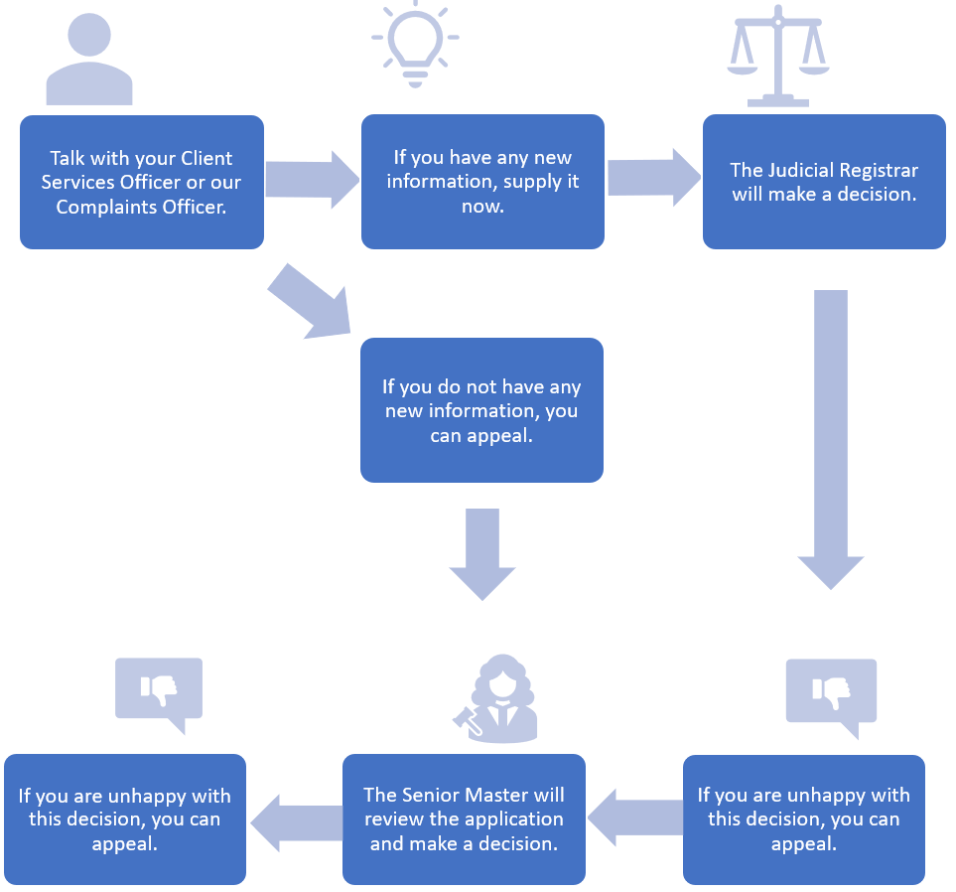

# Talk with your Client Services Officer or our Complaints Officer

Please talk with your Client Services Officer (CSO) first. If you are not comfortable talking about an appeal with your CSO, you can contact our Complaints Officer.

You can contact our Complaints Officer by:

* calling us on 1300 039 390 (or on +61 3 9032 3777 if you are outside Australia) and asking to be put through to the Complaints Officer
* emailing us at [requests@fundsincourt.vic.gov.au](mailto:requests@fundsincourt.vic.gov.au) with ‘Attention: Complaints Officer’ in the subject line
* filling in the complaint form on our website [www.fundsincourt.vic.gov.au](http://www.fundsincourt.vic.gov.au)
* calling us on 1300 039 390 (or on +61 3 9032 3777 if you are outside Australia) to get a printed copy of the complaint form mailed to you.

# Do you have any new information?

Please tell your CSO or the Complaints Officer if anything has changed since you made the application. Give them as much information as you can.

If you have new information, your CSO or the Complaints Officer may be able to resubmit your application to the Judicial Registrar. This is the fastest way to get your application looked at again.

If you do not have any new information, you will need to appeal the Judicial Registrar’s decision.

# How to appeal the Judicial Registrar’s decision

## How much time do you have to start an appeal?

You have a certain amount of time to start an appeal. The amount of time depends on what kind of decision the Judicial Registrar has made.

If the Judicial Registrar has made a decision to dismiss or partly dismiss an application, you have one calendar month from when you receive the order which formally records that decision to appeal.

If the Judicial Registrar has made a decision to grant, or partially grant, an application, you have five business days from the date the order was made which formally records that decision to appeal.

You will usually be informed of the decision of the Judicial Registrar before an order is made.

## How do you start an appeal?

Tell your CSO or the Complaints Officer that you want to appeal the Judicial Registrar’s decision. You should do this as soon as your CSO informs you of the Judicial Registrar’s decision. You do not need to wait for the orders to be made. This is the start of the appeal process.

If they haven’t already, the Judicial Registrar will then make an order that formally records their decision. We will send you a copy of this order.

Your CSO or the Complaints Officer will give the Senior Master all of the information about your application for your appeal.

You do not need to do anything further.

## What happens during the appeal?

The Senior Master will review your application as if it is a new application. The Senior Master will get all the information you gave to Funds in Court.

The Senior Master will make a decision about your application. They will either:

* make an order that is the same as the one made by the Judicial Registrar
* make an order that is different to the one made by the Judicial Registrar.

Please note that the Senior Master can make any order they think is right. This means the outcome of the appeal may not be what you were hoping for.

## Do you need to go to Court?

No.

You do not need to go to Court or go to a formal hearing.

## Will it cost you any money?

No.

# How to appeal the Senior Master’s decision

If you are unhappy with the Senior Master’s decision you can appeal it. Read our Information Sheet ‘Appealing a Decision Made by the Senior Master’ to find out more. This is available on our website [www.fundsincourt.vic.gov.au](http://www.fundsincourt.vic.gov.au) or you can call Funds in Court on 1300 039 390 (or on +61 3 9032 3777 if you are outside Australia) to get a printed copy mailed to you.

# What if you want to complain about the conduct of the Judicial Registrar?

If you want to complain about inappropriate conduct by the Judicial Registrar, or matters that may affect their performance of their role as Judicial Registrar, you can complain to the Judicial Commission of Victoria. Please note that they do not investigate complaints about the correctness of a decision. They only investigate complaints about the conduct or capacity of a judicial officer. You can find more information at [www.judicialcommission.vic.gov.au](http://www.judicialcommission.vic.gov.au).