Follow the steps below if you want to appeal a decision made by the Senior Master.

# Information Sheet

# Appealing a Decision Made by the Senior Master

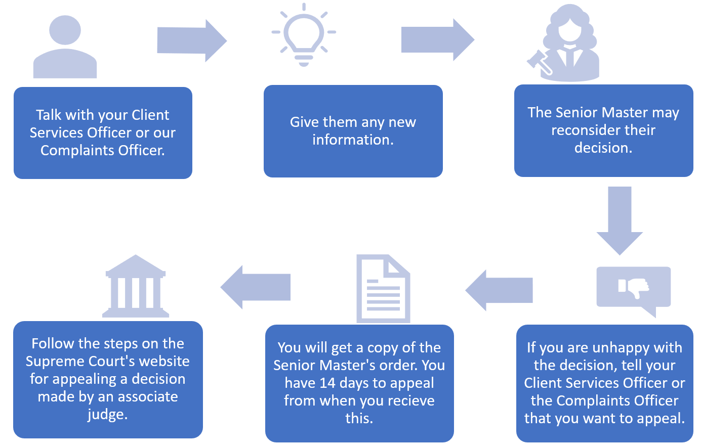

# Talk with your Client Services Officer or our Complaints Officer

Please talk with your Client Services Officer (CSO) first. If you are not comfortable talking about an appeal with your CSO, you can contact our Complaints Officer.

You can contact our Complaints Officer by:

* calling us on 1300 039 390 (or on +61 3 9032 3777 if you are outside Australia) and asking to be put through to the Complaints Officer
* emailing us at [requests@fundsincourt.vic.gov.au](mailto:requests@fundsincourt.vic.gov.au) with ‘Attention: Complaints Officer’ in the subject line
* filling in the complaint form on our website [www.fundsincourt.vic.gov.au](http://www.fundsincourt.vic.gov.au)
* calling us on 1300 039 390 (or on +61 3 9032 3777 if you are outside Australia) to get a printed copy of the complaint form mailed to you.

# Do you have any new information?

Please tell your CSO or the Complaints Officer if anything has changed since you made the application. Give them as much information as you can.

If you have new information, your CSO or the Complaints Officer may be able to resubmit your application to the Senior Master. This is the fastest way to get your application looked at again.

If you do not have any new information, you will need to appeal the Senior Master’s decision.

# How to appeal the Senior Master’s decision

## Tell us that you want to appeal

Tell your CSO or our Complaints Officer that you want to appeal the decision.

The Senior Master will make an order that formally records their decision. We will send you a copy of this order.

## How much time do you have to start an appeal?

You have 14 days from the day you receive the Senior Master’s order to start your appeal. If you need more than 14 days, you or your lawyer can ask the Senior Master or the Judge who is hearing the appeal for more time. It is best to ask for more time as soon as you think you might need it.

## Think about hiring a lawyer

We recommend that you hire a lawyer. A lawyer can:

* give you advice
* help you to prepare the documents for the appeal
* speak for you at the hearing of the appeal.

If you hire a lawyer, you should give them a copy of the Senior Master’s order as soon as you get it. Give them any other relevant information so they can give you advice and prepare the appeal documents.

Alternatively, you can represent yourself in Court. This is called being a ‘self-represented litigant’. The Supreme Court has information to help self-represented litigants [appeal a decision made by a Supreme Court associate judge](https://www.supremecourt.vic.gov.au/going-to-court/representing-yourself/appeal-or-review-a-decision/appeal-a-decision-made-by-a-supreme-court-associate-judge).

You can talk to the Self-represented Litigant Coordinator at the Supreme Court. They can help you with questions and look into possible free and low-cost legal help. You can contact them by:

* calling +61 3 8600 2031
* emailing [unrepresented@supcourt.vic.gov.au](mailto:unrepresented@supcourt.vic.gov.au).

## How do you start an appeal?

The Senior Master is an Associate Judge of the Court. You will need to follow the steps on the Supreme Court website to [appeal a decision made by an associate judge](https://www.supremecourt.vic.gov.au/going-to-court/representing-yourself/appeal-or-review-a-decision/appeal-a-decision-made-by-a-supreme-court-associate-judge).

To start an appeal, you need to:

* Complete a ‘Notice of Appeal from an Associate Judge’ form. You can download a copy of the Notice of Appeal form from the [Supreme Court website](https://www.supremecourt.vic.gov.au/forms-fees-and-services/forms-templates-and-guidelines/notice-of-appeal-from-an-associate-judge).
* Serve a copy of your completed ‘Notice of Appeal from an Associate Judge’ form on the relevant parties.
* File your completed ‘Notice of Appeal from an Associate Judge’ form and a list of the persons who have been served with the Supreme Court Registry. You will need to pay a filing fee.

There are rules about what you need to include in the Notice to Appeal, who the Notice of Appeal must be served on and when each step must be completed. Please refer to the information on the [Supreme Court website](https://www.supremecourt.vic.gov.au/going-to-court/representing-yourself/appeal-or-review-a-decision/appeal-a-decision-made-by-a-supreme-court-associate-judge), talk to your lawyer or talk to the Court’s Self-represented Litigant Coordinator.

## Do you need to go to Court?

Yes.

Appealing a decision made by the Senior Master is a formal appeal to a judge of the Supreme Court. The judge will hold a hearing at the Court.

## Will it cost you any money?

Yes.

You will need to pay Court costs, such as a filing fee. If you decide to hire a lawyer you will need to pay their fees.

You can apply to use your funds in Court to pay for an appeal.

# What if you want to complain about the conduct of the Senior Master?

If you want to complain about inappropriate conduct by the Senior Master, or matters that may affect their performance of their role as Senior Master, you can complain to the Judicial Commission of Victoria. Please note that they do not investigate complaints about the correctness of a decision. They only investigate complaints about the conduct or capacity of a judicial officer. You can find more information at [www.judicialcommission.vic.gov.au](http://www.judicialcommission.vic.gov.au).