At Funds in Court (FIC), we need your bank account details so we can make payments to you.

Information Sheet

Providing Your Bank Details

# What information do you need to give us?

To make sure that we are putting money into the right account, we need specific information.

We need your:

* bank account name
* BSB number
* account number.

We need this information on the bank letterhead to show it is an official document from your bank.

Please note we do not accept:

* screenshots that do not show all of the information and bank logo on one screen
* emails from your bank.

# Where can you find this information?

You can find this information in:

* your bank statements
* letters from your bank
* a proof of account letter from your bank
* a proof of balance letter from your bank.

We have included examples of some of these below.

# How can you get this information?

## Internet banking or banking app

You can find this information online. You can call or chat to your bank to get their help with finding and downloading any of these documents. The information you need is often found under a heading called:

* Statements
* View Statements
* e-Statements
* Proof of Balance
* Proof of Account.

Download the statement, proof of balance letter or proof of account letter.

## At a bank branch

You can ask a person at a bank branch to print or email you:

* a copy of a recent bank statement
* a proof of balance letter
* a proof of account letter.

## From a paper statement

If you have a paper copy of a recent statement, you can take a photo or scan the page that shows your bank account details and the bank letterhead.

# How do you send the information to FIC?

You can crop out or cover your transaction history and account balance if they appear. We don’t need this information.

Email or post the information to us. You can email it to [requests@fundsincourt.vic.gov.au](mailto:requests@fundsincourt.vic.gov.au) or post it to Funds in Court, Supreme Court of Victoria, 210 William Street, Melbourne, Victoria 3000.

If you have any questions, please talk to your Client Services Officer. You can call them on 1300 039 390 or email [requests@fundsincourt.vic.gov.au](mailto:requests@fundsincourt.vic.gov.au).

# Examples

Please note we have covered the account information in these examples. When you give us your information, please do not cover the:

* bank account name
* BSB number
* account number
* bank name and logo.

You can cover your transaction history and account balance if they appear.

## Proof of balance letter from Westpac

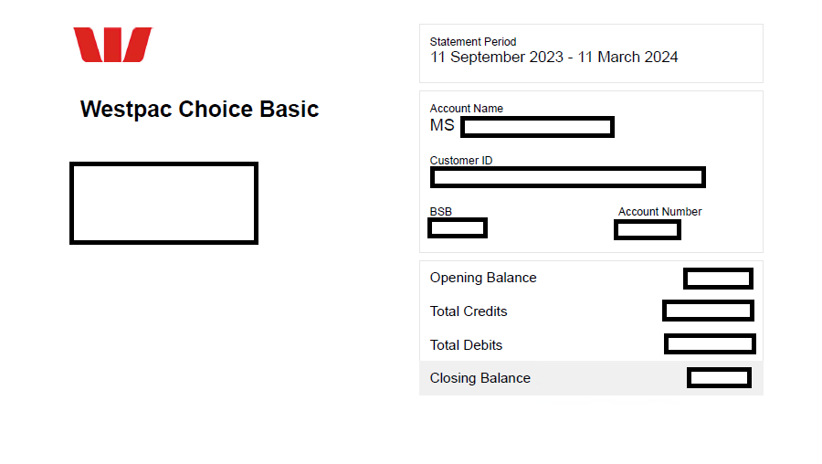

## Proof of account letter from Bendigo Bank

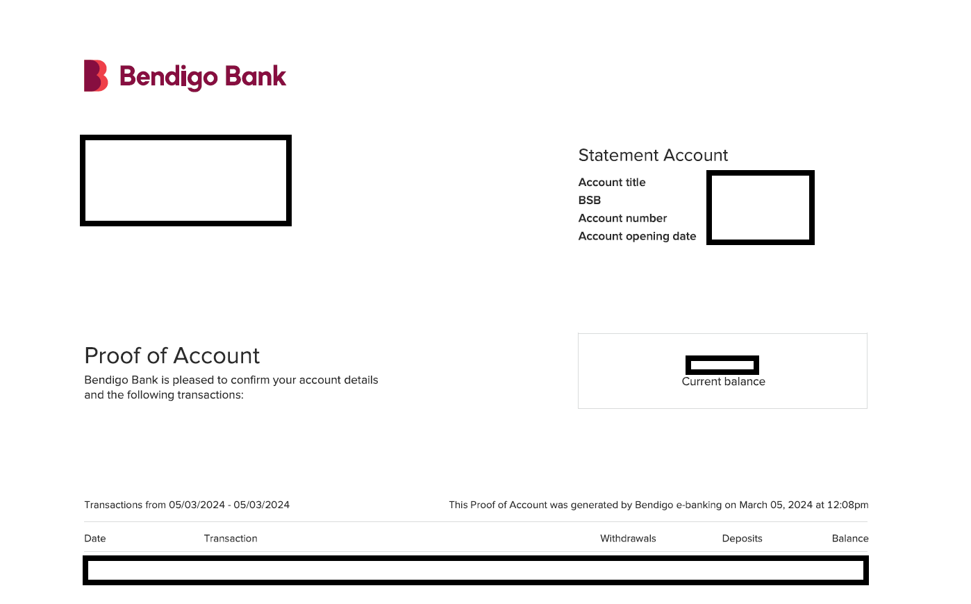

## Proof of account letter from Commonwealth Bank

